Usage of the job aid:

Job aids are helpful in scenarios. In this case. The training of new employees. Job aids can be used for references. It helps to get rid of steps that are not needed and to ensure that all employees are trained in similar ways.

Introduction:

With data analysis projects. It’s always important to lay out standards or goals. In this case. The police department requested us to create a SCDR which stands for Storm and Crime Data Report. This helps set the goal of the project and helps to determine the parameters of the project. At times, parameters can complicate steps, thus, planning steps that are laid out can ensure that the team does not lose focus for the end goal. With this goal in mind. We can start to build the report. The goal is to create a visual board made with data that the police department has provided to us. Specifically, historical data from Miami from October 1st, 2019, through October 31st, 2019. In short, the Miami police department wants to use the visual data for timeframes that crimes are the highest from storms to prevent future crimes.

Section 1 Types of Analysis:

With the goal in mind. The Miami police department needs to use the SCDR for future crime. To make this possible. They have provided us with historical datasets from October 1st, 2019, through October 31st, 2019. Along with the datasets provided, there may be some problems that may arise. For starters, there is one dataset that we can use as a sample. This is enough to not being able to provide information that is reliable for the Miami police department to work with. Also, other factors that may arise would be the year, storm types and the different array of areas that crime may have been committed in Miami. We would have to use a technique called predictive analysis. With this technique we must compare historical and current patterns to help predict the future of crime. Reason for this technique is that for this one sample dataset it will help use reach the end goal. This in turn will help the Miami police department predict patterns of when crime will be at its highest during storms.

Section 2 Parameters and collection of data:

With weather and crime. We can use different analysis parameters. We can use a parameter that include crimes from not so severe to very severe. Giving the dataset that was produced from the Miami Police Department. As for storms, we can set parameters such as categories from not so severe of a storm to very severe storm from the dataset provided by the Miami Police Department.

Section 3 Selection of tools:

There are a variety of tools we can use to extract raw data make the raw data meaningful for the Miami Police Department. We can use Excel sheets to transform the data into charts or graphs that can make the understanding of the data readable to individuals and help make correlations of crime and storm. We can produce a chart to show an example. For the sake of this job aid. We will keep it clean and simple. In short, the charts will report the types of storms and crime reported from October 1st, 2019, through October 31st, 2019. A follow up chart can be created as well to show correlations from crimes and storm from different Miami towns and counties. In refence to examples, I will provide the charts and graphs in a separate document.

Sections 4 Validation:

When using Excel. There is no need to enter the scripting manually. All you need to do is clean the datasets. In this case, from the datasets provided by the Miami Police Department. We can remove ID, event IDs such as storm and crime and the zoning ID’s. It will help with lessening the data to only particular fields being looked for. It will help with graphing and creating a pivot table to produce the graphs with accuracy that are deemed valid. Then, you use the cleansed data you have created and begin using data analysis techniques. Using data analysis techniques helps in creating the graphs and reports that will help to meet our end goal. Thus, a report that the Miami Police Department can use to help prevent future crimes by predicting future patterns.

Storm and Climate Data Record (SCDR)
Implementation Plan

I. Introduction

1.1 Overview and purpose
To bring to light the purpose of this report. The Miami Police Department has requested us to make correlations between storms events the crime rates. This type of report is to be used by the Miami Police Department to help prevent future crimes and prevent personal losses.

1.2 Define why you need data analysis
In this type of requested report. What would need to use is historical data to perform the proper analysis. Reason being, Miami Police Department requested a report to help prevent future crimes and thus historical data needs to be sourced to be used for this type of data analysis.

II. Data Preparations

2.1 Name data sources
The dataset that was provided was provide by the Miami Police Department. It shows data that has records of crimes, storms and as well as loses of personal value.

2.2 Filter through unnecessary data
Analyzing the datasets that was provided by the Miami Police Department. It appears that there were no unnecessary data that had to be cleansed. Thus, resulted in a clean dataset to work with.

2.3 Define your parameters
Parameters that were used is two simple variables. They were the time frames from January 1st, 2017, through December 1st, 2019. Another parameter that was used was the crimes the occurred during storms and no storms.

2.4 Identify measurement priorities
With the parameters in placed. Crimes that occurred during the storms and no crime that did not occur during no storm would be measured. Since, the Miami Police Department only wants to use this report to predict future crimes during storms.

2.5 Ensure collected data fits the need
As explained previously. The collected data would only be used to help predict future crimes during storms by the Miami Police Department.

III. Data Analysis

3.1 Identify scripts used
The scripts used in R are as followed:

install.packages("tframe");
install.packages("tfplot");
library("tframe");
library("tfplot");

setwd("C:/Users/Public/Desktop/DAT-375")

crimestormdataQ <- read.csv("crimeStormQ.csv")
print(crimestormdataQ)

crimenostormdataQ <- read.csv("crimenostormQ.csv")
print(crimenostormdataQ)

z<-ts(cumsum(crimestormdataQ$Loss)/1000,start=c(2017,1), frequency=12)
x<-ts(cumsum(crimenostormdataQ$Loss)/1000,start=c(2017,1), frequency=12)

tfplot(z,x,
ylab="Victim Loss in K$",
xlab="By Month by Year",
title="Victim Loss From Crimes for Jan 2017 - Dec 2019",
subtitle = "Cumulative Loss in Thousands of Dollars",
legend=c("Crimes During Storms (black)", "Crimes When No Storms (red)"),
source="Source: DAT Data")

3.2 Run the scripts to analyze the data and validate the output
[Insert text description.]

IV. Drawing Conclusions

4.1 Present the results of the analysis to stakeholders
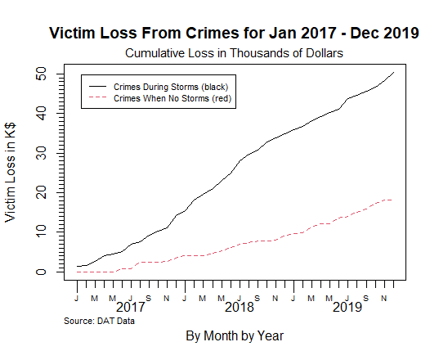
The graph above displays crimes during storms and crime during no storm. Its in order by the Years listed on the bottom of the graph.

4.2 Determine whether the problem was addressed, including any challenges and limitations

The challenge that was found was that there was only enough data for the past three years. In short, such short variables has affected the result of the report. Limitations as well were in place do to the geography of such locations and no storm during some of the months. In short, Miami was the only city that the dataset was pulled for as there can be other cities as well that can be impacted by crimes during storms.

4.3 Report potential new findings

The determinations on the graph as well as the analysis of the data shows that there are some correlations with crime and storms. The graph displayed shows no dip during storms or no storms as well as no dips in crimes during both storms and no storms.

install.packages("tframe");
install.packages("tfplot");
library("tframe");
library("tfplot");

setwd("C:/Users/Public/Desktop/DAT-375")

crimestormdataQ <- read.csv("crimeStormQ.csv")
print(crimestormdataQ)

crimenostormdataQ <- read.csv("crimenostormQ.csv")
print(crimenostormdataQ)

z<-ts(cumsum(crimestormdataQ$Loss)/1000,start=c(2017,1), frequency=12)
x<-ts(cumsum(crimenostormdataQ$Loss)/1000,start=c(2017,1), frequency=12)

tfplot(z,x,
ylab="Victim Loss in K$",
xlab="By Month by Year",
title="Victim Loss From Crimes for Jan 2017 - Dec 2019",
subtitle = "Cumulative Loss in Thousands of Dollars",
legend=c("Crimes During Storms (black)", "Crimes When No Storms (red)"),
source="Source: DAT Data")

