[Project Plan](https://learn.snhu.edu/d2l/le/content/1159488/viewContent/20439484/View" \o "'3-2 Project One: Project Plan' - Assignment)

*Table 1. Stakeholder Register*

|  |  |  |  |
| --- | --- | --- | --- |
| **Name** | **Role** | **Influence** | **Influence On the Project** |
| Adam Lee | Project Manager | Low | Responsible for the success and completion of the project. |
| Brandon King | Project Manger | Low | Responsible for the success and completion of the project. |
| Reynardo Alamo | Software Architect | High | Responsible for the design and other high-level projects to meet solutions for the objectives. |
| Genny Losofiths | UI Designer | High | Creates ideas and illustrates the design of the project. |
| Samantha Caitlin | UI Developer | High | Creates ideas and illustrates the design of the project. |
| Sonia Morales | Tech Team Leads | Medium | Manager that oversees the entire tech team on issues related to software development. |
| Theodore Michaels | Software Developer | Medium | Creates backend codes and scalable solutions for codes. |
| Erwin Smith | Software Tester | Low | Tests the software with certain testing activities. Reports errors and findings to upper leadership |
| Michele Bickman | Software Tester | Low | Tests the software with certain testing activities. Reports errors and findings to upper leadership |

*Table 2. Risk Register*

|  |  |  |  |  |  |
| --- | --- | --- | --- | --- | --- |
| **Description** | **Probability** | **Impact** | **Response Plan** | **Risk Responsibility** | **Status** |
| Compatibility of software system. | Low | High | Ensure testing is done in a timely manner. | Software Architect | A (Active) |
| Sources that are required and or limited. | High | High | Proper planning for the duration of the project. | Project Manager | A (Active) |
| Projects may take longer than allowed. | Low | High | Effective strategies to allow the release of the software in a timely manner. | Project Manager | A (Active) |
| Development of software by skilled software writers. | High | Medium | Leads the software team and tech team in the correct way to ensure the completion of the project | Software Architect | A (Active) |

*Table 3. (WBS) Work Breakdown Structure*

XYZ Business Workflow

Software system testing

Software system testing

Software system testing

Feature Development (3)

Feature Development (2)

Feature Development (1)

Software system development

UI and Development

Requirement Analysis

*Table 4. Responsibility Assignment Matrix*

|  |  |  |  |  |  |  |  |  |  |
| --- | --- | --- | --- | --- | --- | --- | --- | --- | --- |
| Project manager | Project Manager | Software Architect | UI Developer | UI Design | Tech Leads | Tester | Tester (2) | Tester (3) | Tester (3) |
| Required Analysis | A | A | A | A | A | A | A | A | A |
| Development Featured (1) | I | I | I | I | I | I | I | I | I |
| Development Featured (2) | I | I | C | C | C | C | I | I | I |
| Development Featured (3) | I | I | I | I | I | I | I | I | I |
| Customized Featured (1) | I | C | C | C | C | C | C | C | C |
| Customized Featured (2) | I | C | C | I | I | C | C | C | C |
| Customized Featured (3) | I | I | C | C | C | C | C | C | C |
| System Testing | R | R | R | R | R | R | R | R | R |

**R= Responsibility A=Accountability C=Consultant I= Informed**

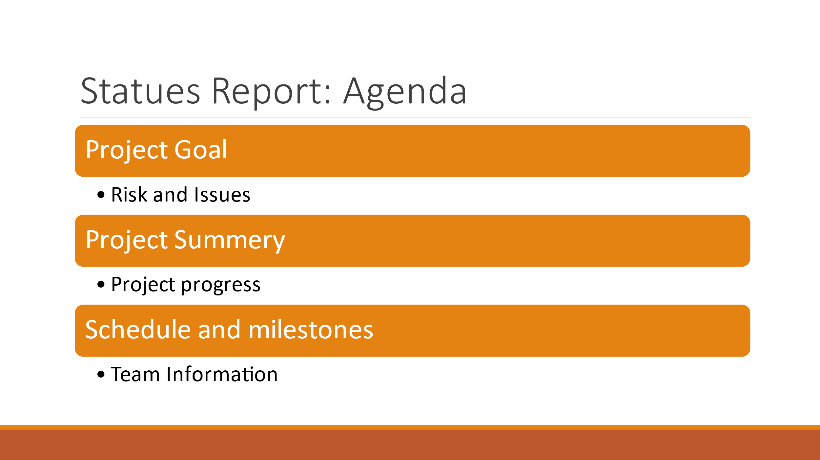



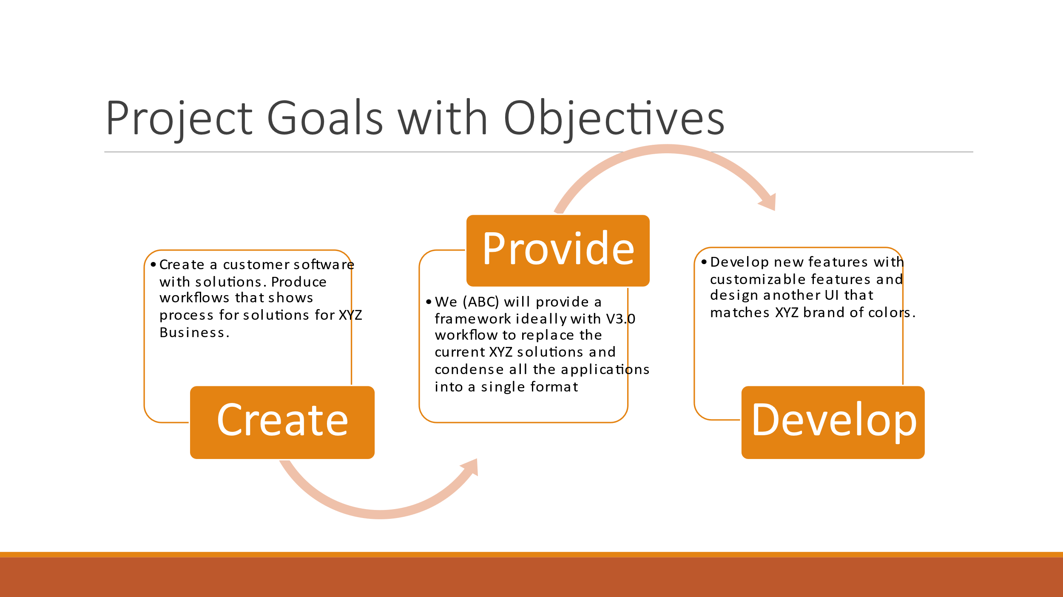

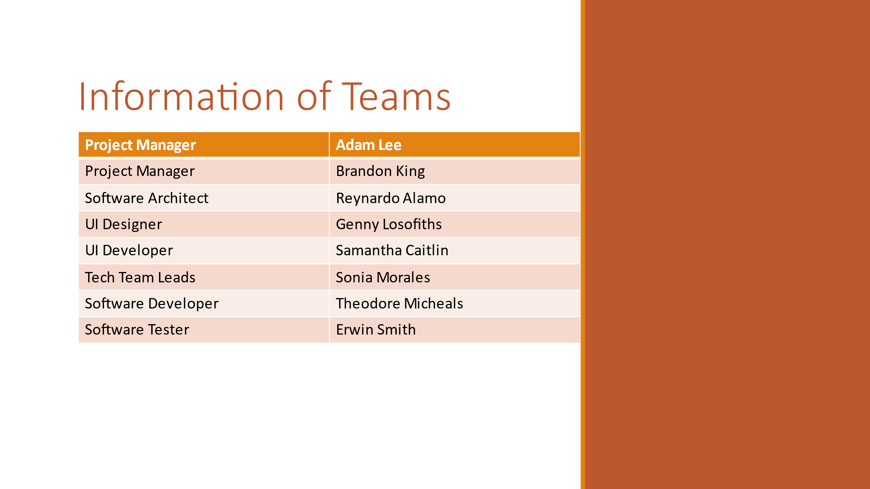

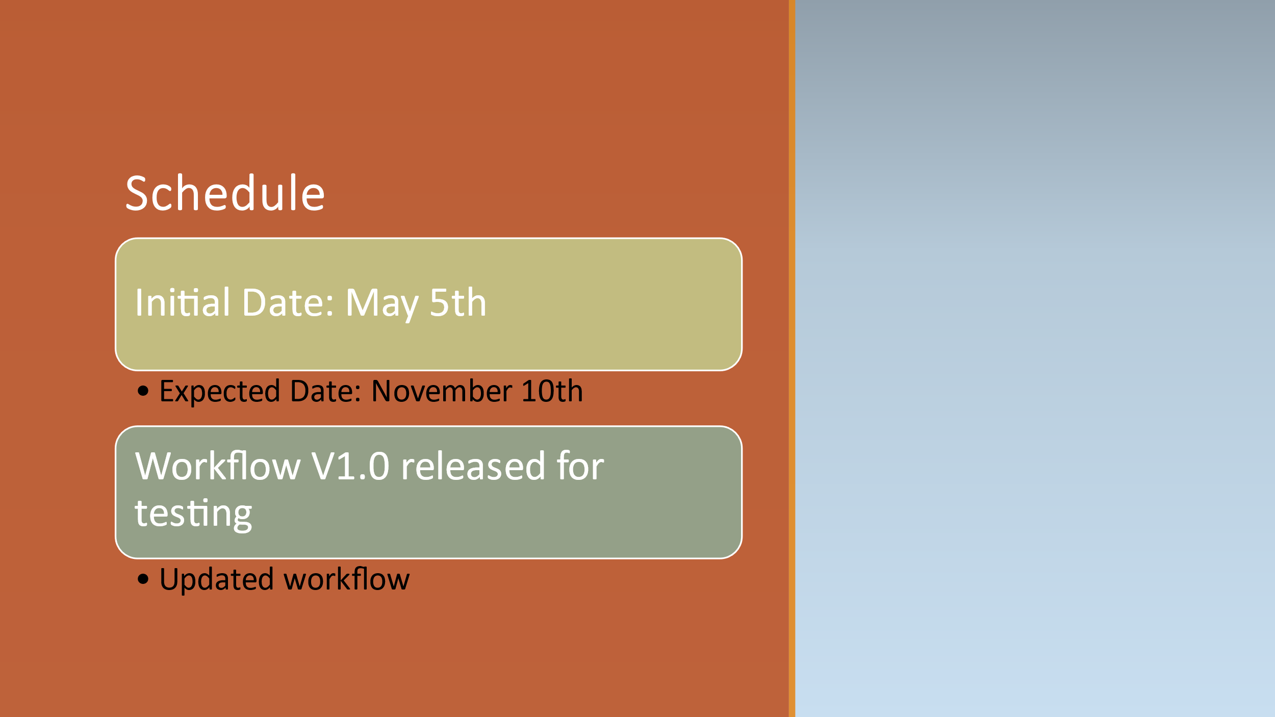

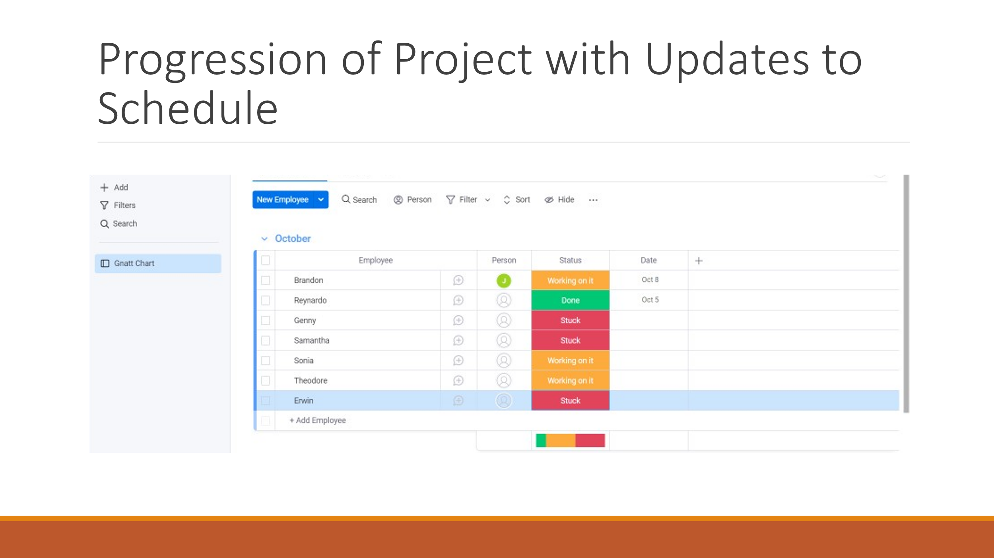

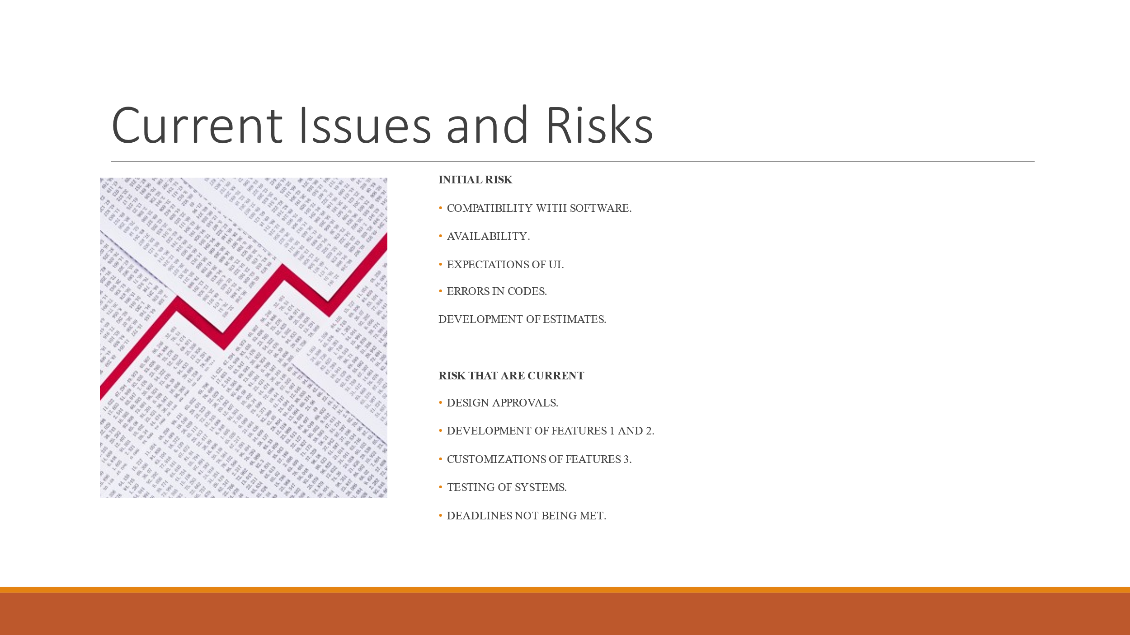

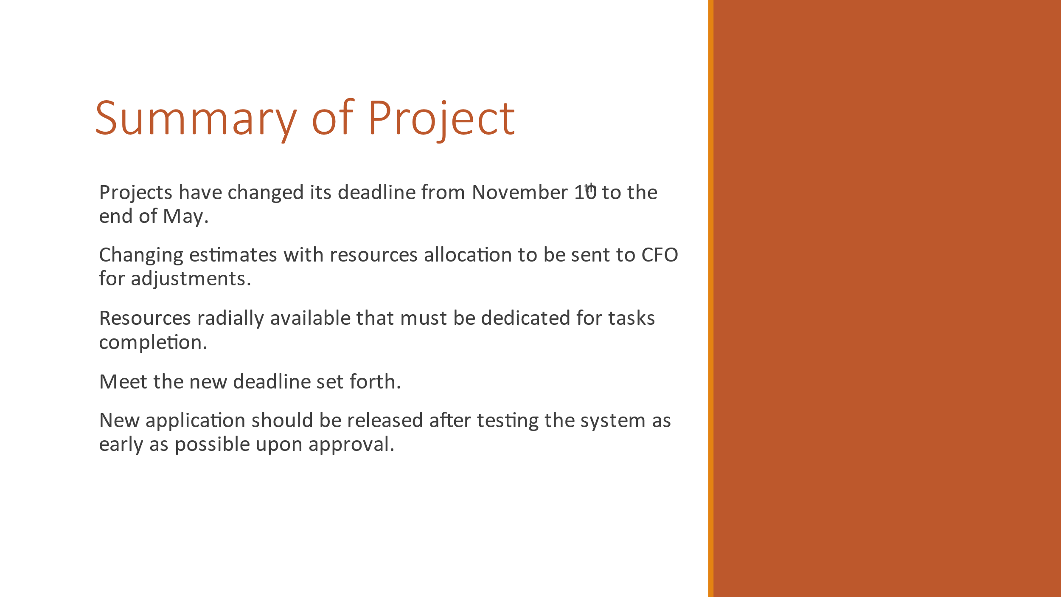

[Project Analysis and Recommendations](https://learn.snhu.edu/d2l/le/content/1159488/viewContent/20439512/View)

**Introduction**

Introduction to this presentation is to show the analysis dome for the first phase of the development of the software for XYZ financial as well as recommendations for phase two. Included within this introduction are findings of objectives that had minor and major tasks:

* XYZ needed for us to come up with solutions for customizable software for their financial services.
* Made accommodations for objectives completion as well as delivering a solution on the time frame agreed upon.
* Testing of software before launch as well as usability.

**Project Success**

The time spent on this project was made viable due to the sheer effort and hard work as well as long hours put forth by the team in seeing the completion of this project. Despite some accommodation from the executive team and last-minute request to make changes as well as two valuable team members resigning. The team as a “WHOLE” were able to overcome obstacles, display vitality and perform well under conditions that most would not have been able to work under. Meaning, the pressure that was put on the entire team was eliminated through cooperations, teamwork and communication.

**Project Failures**

There were two valuable team members who resigned due to unforeseen circumstances. Although, we were able to find replacement for their vacancy. A new hire had to be trained by another team member to come up to speed and work on the continuance of the project. Second, the executives were reluctant to provide ample time to accommodate their request of testing and ingredients. In short, the team faced challenges that were out of their will and power. Meaning, they were not given additional time and had to work some weekends as well as long hours (12hrs) Wednesday, Thursday, and Friday. Which caused an ample amount of stress for the integrity and structure of the team.

**Project Challenges**

1. Product request changes made by the executives hinder the progress slightly since the request was made near the completion of the project. Despite not being able to wait until phase two. Accommodations were made to seek that the request was integrated into phase one of the project.
2. Two valuable team members resigned, and two new team members were hired. One new hire had the experience and skill set. The other new hire needed to be trained by another team member on the team to bring them up to speed. To avoid this type of challenge in the future of this project. XYZ financial services can focus on hire internal to ensure that the team members can work effectively together as well as displaying work-ethic that can be demonstrated on the project.
3. The executives did not provide my team ample time to accommodate request made towards the completion of the project.
4. After the release of the software. Front end users (consumers) faced challenges with software issues. To help alleviate this dilemma in future projects. Teams should receive training on how to usably use any new software and check for errors, fatal errors, and user friendliness. In short, effective training to ensure the software can perform efficiently.

**Phase one of the project: Recommendations for plans on efficiency and release**

1. In the beginning of the project. Teams should establish a positive outlook (expectations) for the completion of the project. If issues arise during the project, it should be communicated while giving ample time to resolve such issues. Meaning, setting priorities and expectations to high standards.
2. To avoid delays. Teams must make an infrastructure that can effectively communicate with one another during and after the release of such projects. A release infrastructure will amend to this accommodation.
3. To have software testing done effectively and efficiently. Any testing should be done regularly without lengthy approvals.

**Recommendations for next project: Phase Two**

1. To showcase support for the team. We must make investments into the team to support their development by providing the right tools and training to ensure that the proper skills are displayed to complete projects.
2. Understand information that are released prior to acting on projects. Meaning, reading about such solutions that were previously achieve during the undertaken of major projects. What loopholes were used and how effectively such problems were solved.
3. A software tool that can be used for future projects is automation. It’s a software that enables the team to do repetitive tasks and not tie up resources. Meaning, extra time that can be used for other tasks on the project. Another suggestion can be setting up standards to ensure both input and output stay consistent.
4. Lastly, a recommendation that I may place. Is to adopt a software (framework) for such project releases. It’s called Systems Development Life Cycle (SDLC). It’s a software that can help plan as well as maintain while replacing software system issues as well as maintaining the quality of the project. I can recommend such system to be put in place for future projects and management processes.