### Introduction

This memorandum report identifies and explains key microeconomic principles using a set of simulation games. The outcome of these games illustrate how microeconomic principles can be applied within real-life situations to help us make better business decisions. This report is a summary of the simulations I played and their results, which include the key takeaways and their significance, for your review and reference. It is divided into the following sections:

1. Comparative Advantage
2. Competitive Markets and Externalities
3. Production, Entry, and Exit
4. Market Structures (including the Price Discrimination and Cournot simulations)
5. Conclusions
6. References

**Comparative Advantage Figure 1.1**

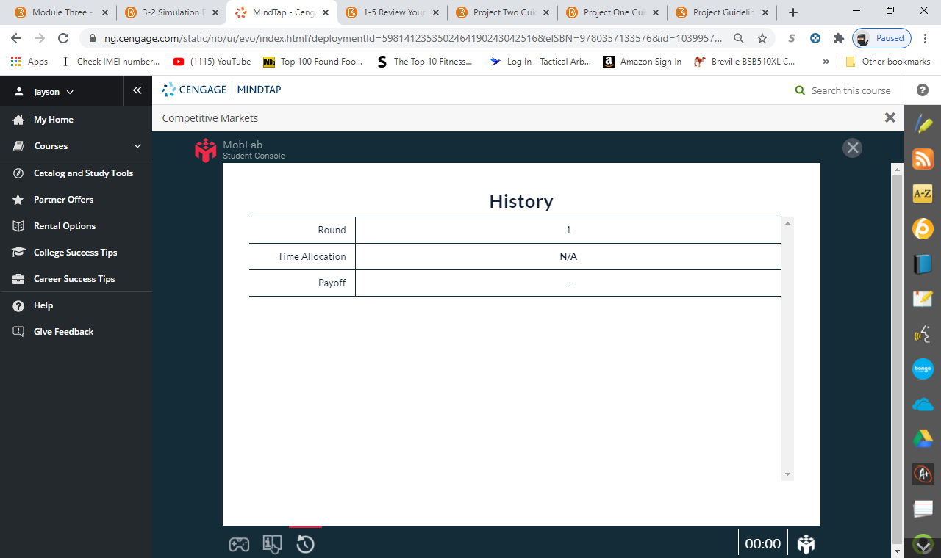

**Figure 1.2**

The simulations above reflect how with trade, the opportunity cost is more appealing than without trade. Money spent elsewhere is money lost in business. Ideally, you must weigh the opportunity cost by the cost and benefits of options available, while weighing it against others. With the graphs above, it shows that with trade the opportunity cost far outweighs cost and benefits than without trades. An example would be a student who spends three hours watching a movie and spent $20 to gain entry to the movies. As opposed to studying for an exam the night before. Those three hours could had been used to prepare the student for the exam and the $20

could had been saved for other items. At times, it may not be in the best interest of a business to proceed, if the cost and benefits don’t make financial sense. Accurately assessing cost and benefits would help businesses make better informed decisions.

### 

### Comparative advantage gives companies’ ability to sell goods and services at lower prices -- as opposed to their competitors, while helping the company who is the sole creator of the product realize stronger sales margins. The downfall to a company having a comparative advantage would be that they lack in certain goods that creates inefficiencies. To compensate for the lack of goods, companies look at other companies that specializes in services that they lack and look for what takes fewer working hours to make those goods. In turn, it helps better the companies to be more efficient, produce better results, all while gaining stronger sales margins and profitability. The business decision to trade would cause changes to their PPF –- production possibility frontier. As companies look to position themselves as the absolute best company for goods and services, they increase their chances of being inefficient. Comparative advantage is a good practice for businesses, only if it makes financial sense to proceed with cost and benefits. In the long run, companies must have the best interest of their business, to grow their margins and increase profitability.

### Competitive Markets and Externalities

**Figure 2.1**

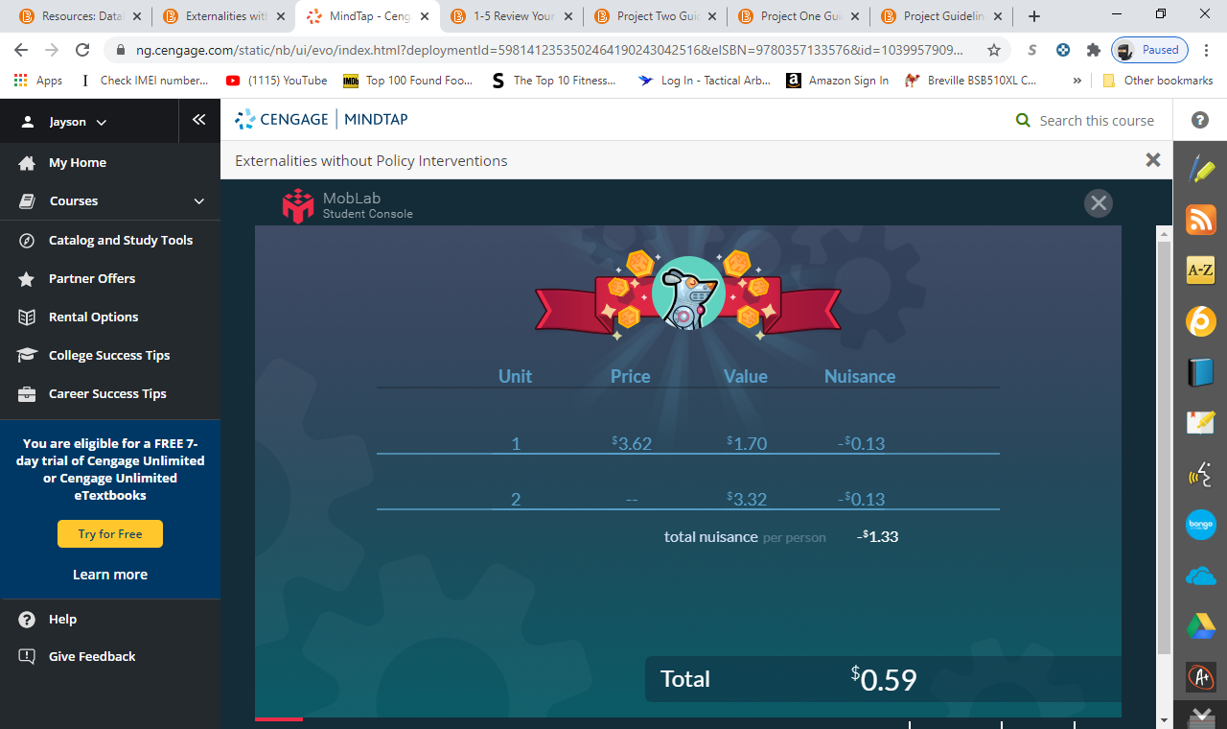

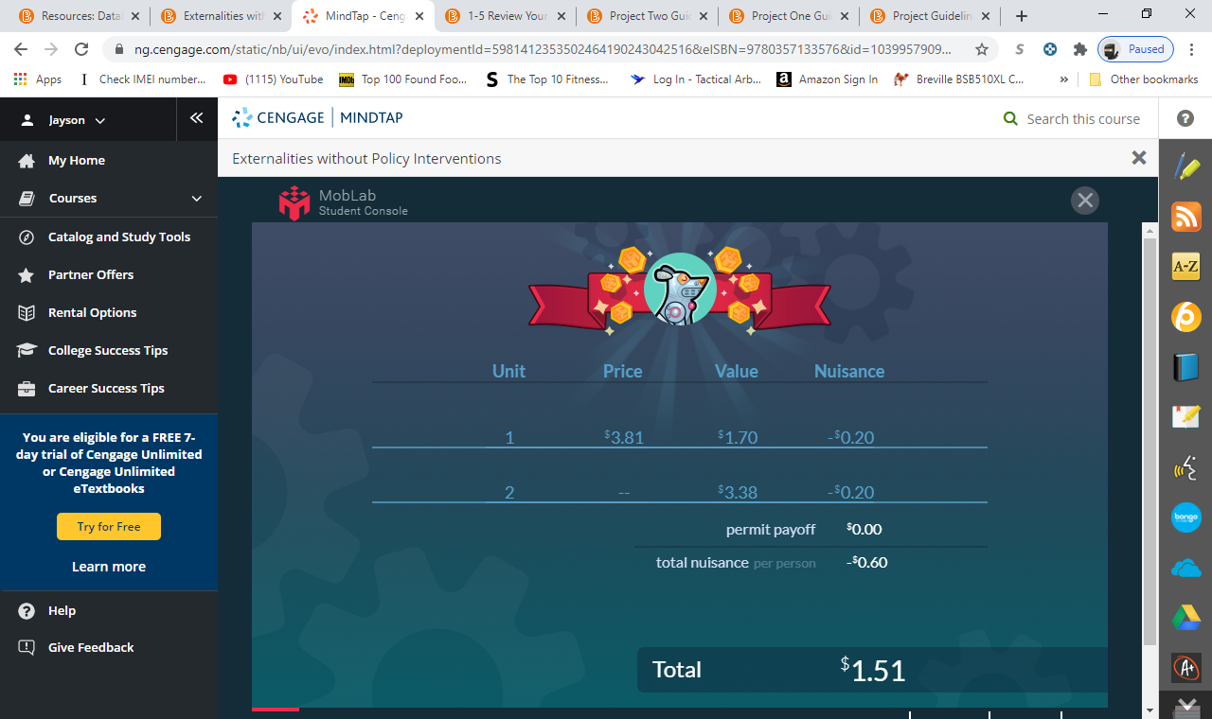**Figure 2.2**

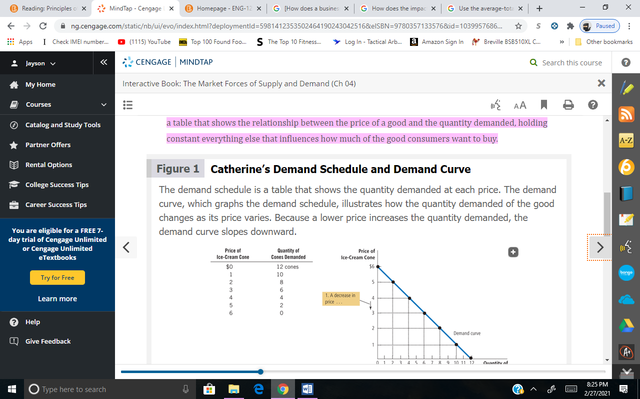 With policy interventions. The impact it has on supply and demand is influence by either a decrease in demand that makes the equilibrium price fall or a decrease in supply that makes the equilibrium price to rise. From the simulation above, it shows that while the oranges where not in demand during certain times of the season. Different seasons either made the oranges more in

demand, thus, increasing quantity in supplying and lowering the equilibrium. As a result, prices were affected across all the simulation.

Determinants are what directly affects a consumer to purchase an item over other goods. For example, the availability of a product that has no substitute, affects what consumers are willing to pay for the item. Another determinant would be if the consumer must search for the exact some product since they failed in finding a close enough substitute for the item. The last determinant that influences a consumer choice would be their budget and the amount of a percentage they are willing to pay for the item. With these three determinants, the simulation above in figure 2.2 shows how consumers were influenced in buying the product that had no close substitute for the original. Price elasticity impacts the firms when the curvature of the curves moves to the right (making profit) or to the left (losing monies). Increasing prices on items would over time decrease the total revenue that firms are able to generate. If consumer spending is inelastic, it means that the demand is not very responsive to the price changes. This is how firms make their decision on pricing and generating total revenue.

From the simulation above, it’s safe to assume that there is a consumer surplus. Meaning, it what was consumers were willing to pay for the product. In turn, consumers were willing to pay an upscale price for the same item that was in demand. For a producer surplus to happen, the producer would have to be willing to accept a lower price than what the market price for the items are. These are the specific reasons in explaining the graphs above, justifying why it’s a consumer surplus.

### Production, Entry, and Exit

**Figure 3.1**

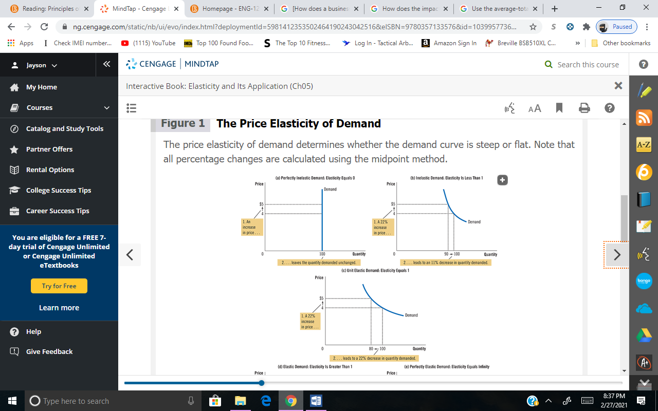 As potential business owners, we must look into how we can enter the markets. For example, with proper research, we can identify are specific customers and understanding our competition. With those two analyses, we can than figure out our markets and what we are going to get into. With the simulation, it showed what and when we made profit for days that were either slow or fast. Another analysis would be to determine what state the market you are going to enter is in. Without understanding the market, it can hurt our business in the long run. Thus,

making our business lose money as opposed to gaining potential profits. With the above analysis, we can base our decision to enter the market and view how our competitors react to the markets.

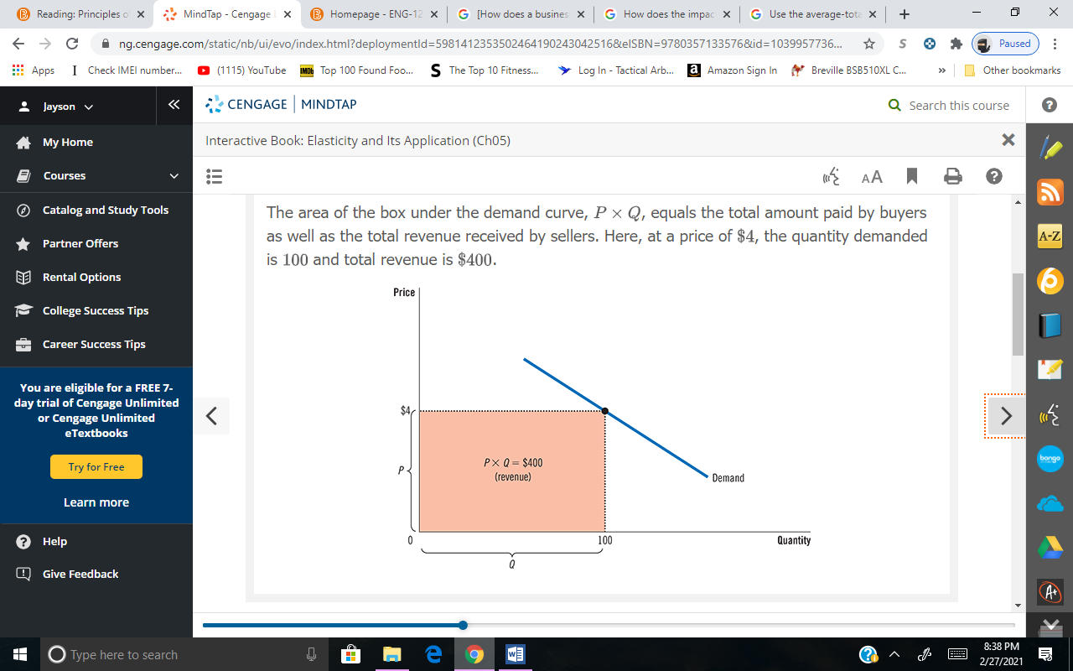Marginal cost is a valuable decision-making skill. It helps businesses set prices, compare models with one another, set supply levels and choose which products are worth producing and what products are going to be discontinue. With the graph above, the hours were determined by the day and how much profit the business the generating. Giving more hours to the drivers made less profit for the business, thus, resulting in cutbacks on drivers to keep the business up float. Marginal cost was also calculated by the production level of the drivers and the consumers

buying items from the business. In some instances, hours for drivers were greatly affected by the number of items that were being produce. Resulting in more profits for the business and less income for the drivers for the day.

The impact that fix cost would have on our business would have no impact on the short run of the business. In the long run of the business, it would affect our profits and our potential to grow our business bigger to generate stronger profits. As the charts below implicates, shows different routes we can take for a short run of our business, as well as the long run of our business. With the ATC model, especially in a competitive market, it marks where our margins are versus where our production is at. With these models, it shows our decision and what approaches we can use to run our business.

### Solved: The Following Graph Shows The Demand (D), Marginal... | Chegg.com

|  |  |  |  |  |  |  |  |  |
| --- | --- | --- | --- | --- | --- | --- | --- | --- |
| **Perfect Competition** | ​​  Infinite | ​  Identical | ​​  Yes | ​​  P>MC | ​​  Yes | ​​  No ​ | ​​  Yes | Amazon, Starbucks, Walmart |

### Market Structures

|  |  |  |  |  |  |  |  |  |
| --- | --- | --- | --- | --- | --- | --- | --- | --- |
| **Oligopolies** | Few Dominant | Differentiated or Identical | Yes | P=MC | No | No | Yes | Warner Media, Delta air lines, Sony BMG |

|  |  |  |  |  |  |  |  |  |
| --- | --- | --- | --- | --- | --- | --- | --- | --- |
| **Market Structure** | **Number of Firms** | **Type of Product Sold** | **Price Taker?** | **Price Formula** | **Freedom of Entry?** | **Short-run Profit?** | **Long-run Profit?** | **Industry Examples** |

|  |  |  |  |  |  |  |  |  |
| --- | --- | --- | --- | --- | --- | --- | --- | --- |
| **Monopolistic Competition** | ​​  Many | ​​  Differentiated | ​​  No | ​​  P<MC | ​​  Yes | ​​  Yes | ​​  No | Uber, Jollibee, Supercuts |

|  |  |  |  |  |  |  |  |  |
| --- | --- | --- | --- | --- | --- | --- | --- | --- |
| **Monopolies** | ​​  One | ​​  Unique | ​​  No | ​​  P=MC | ​​  No | ​​  Yes ​ | ​​  Yes | Netflix, Google, Verizon |

Table 4.1

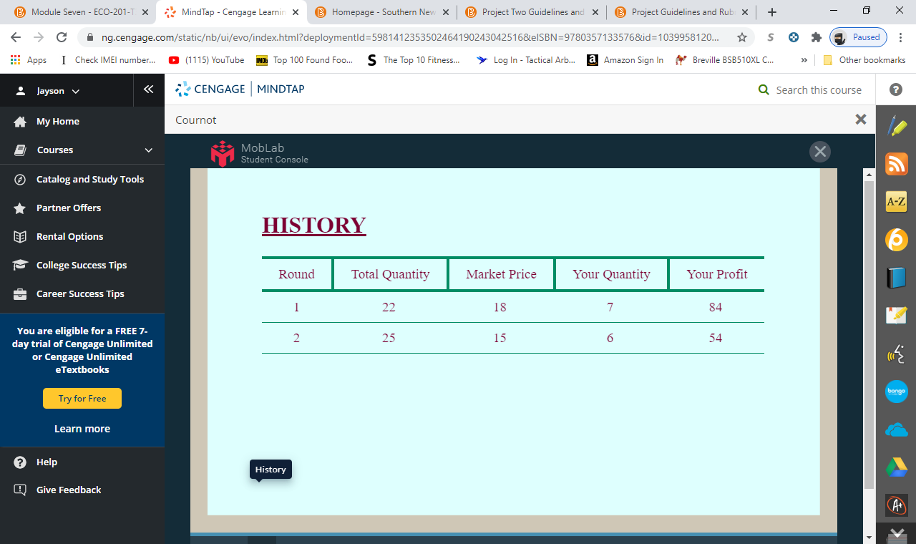

The inefficiencies that derive from monopolistic and monopolies competition is that in a monopolistic company the government privileges certain firms, while in a monopoly is when one firm is the sole controller of the market with having more than 25% or more of the market. With those type of firms, what derives from both is less competition and regulated by the government. With the aim of generating more profits compare to what the market value is, monopolistic company faces less inefficiencies. With a monopolies company, it creates inefficiencies due to competitors placating items at a high marginal cost. The graphs below show examples as to how this type of market (monopolistic and monopoly) creates inefficiencies and or efficiencies.

In a cartel or under the leadership of one firm. Firms collude with one another in an oligopolistic market to set prices for the market to maximize profits. Since firms are in a cartel, there is no price competition that would usually lead to a decrease in profits for the firms. Oligopolistic markets set the output levels for other firms not to become monopolistic. Oligopolistic companies as maximizes their profits by equating marginal revenue with marginal cost. As a result, the demand curves to the left and right because of competition form oligopolistic in the market. These are how companies in an oligopolistic market generate profits while maintaining their margins at optimal levels. With the graphs below, it shows examples as to how being in an oligopolistic market would benefit our company in the long run.

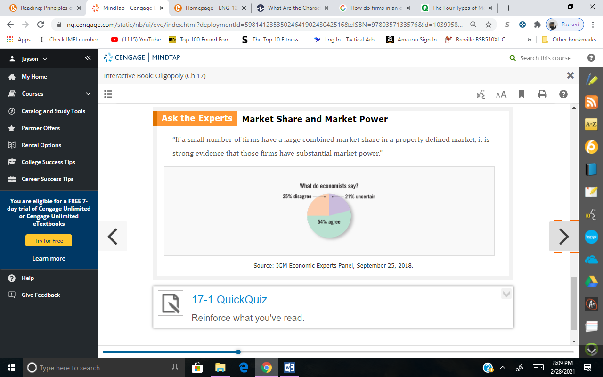

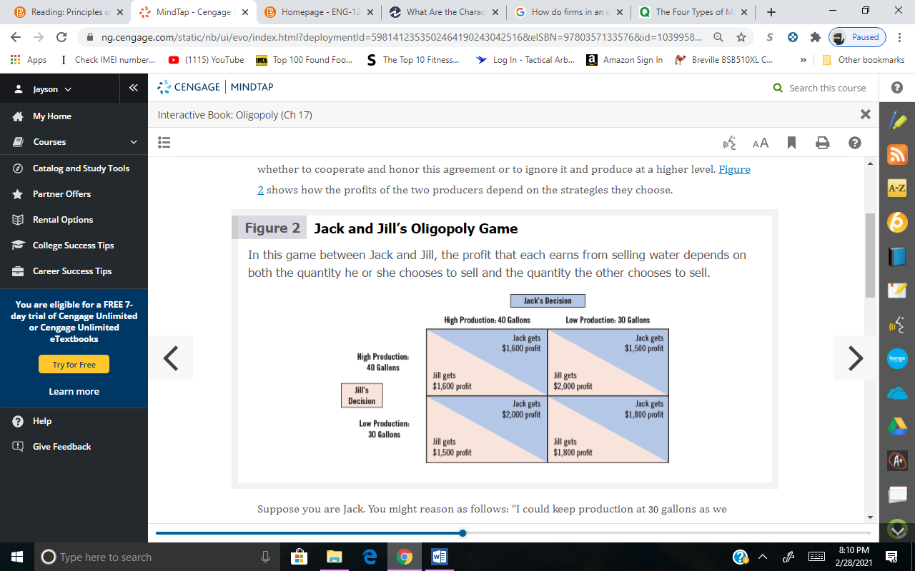

The four types of market structures are perfect competition, monopolistic competition, oligopoly, and monopoly. With perfect competition, there are large numbers of small businesses that compete against each other. Almost all or none of the firms are the sole market power, which all firms equally produce the same output level without having in influence on the market prices. Monopolistic competitors are almost alike the competitors within a perfect market, the difference is that monopolistic companies compete against each other selling similar items at slightly different products. Oligopolistic market is when a small number of firms dominate the market by forming a cartel or having leadership of one company. By competing against each other or colluding with one another, they can use their influence on the market to increase prices and earning more profits. In a monopoly market, a single firm controls an entire market. Creating no entry for other competitors, thus, limiting competition and limiting choices for consumers to seek alternatives. They can also decrease output levels to earn more profits and increase their prices. With these four examples of the different markets, we can choose one of the markets to research and see what our competitions are. The graph below shows an example of the four markets.

### 

### Conclusions

The relevance that microeconomics has on me making a sound decision moving forward with my business, is that it would help me make smart and financial sense in which markets to occupy with my business. Either it being a perfect competitor or an monopolistic competitor, it comes down to my research I have done on the markets and what best fits into what I’m going to enter. The impact it would have on my business depends on how I choose to enter any of which markets. My best recommendation I would suggest for our business would be monopolistic, since we are entering a tech sector. Despite all the other competitors in the tech sector, I assume we will be the top company when it comes to us realizing our potential in our products. All in all, with this extensive research I have done for finding the right market to enter, my result is to enter into the market in which I recommended.