Exploratory Analysis

The supervisors were impressed with our analysis from a previous project we had created. HR has requested us to evaluate the data within the HR Attrition Data that way we can establish a baseline to show HR if there are areas for improvements. With the data that is presented it does show that there are some improvements that can be made within the attrition. Some features can be eliminated, and we can as well create new features. As with the screen shots below. I have created a baseline.

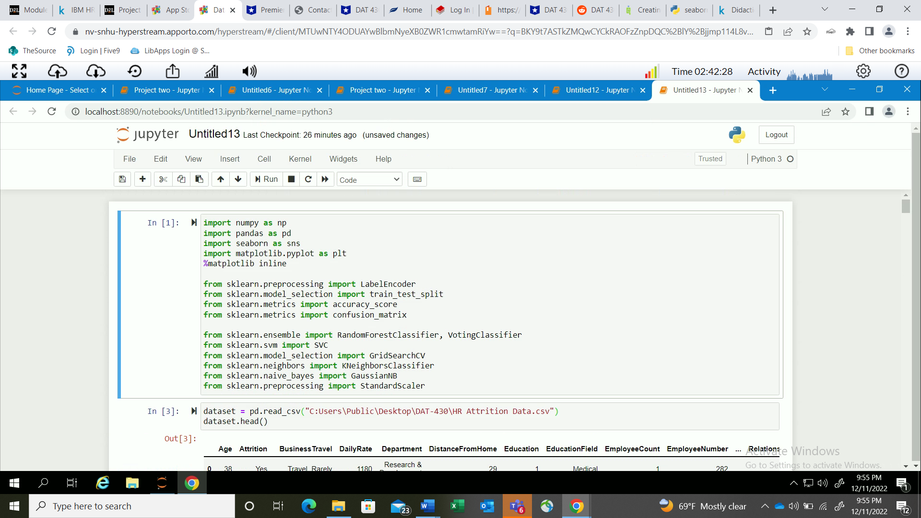

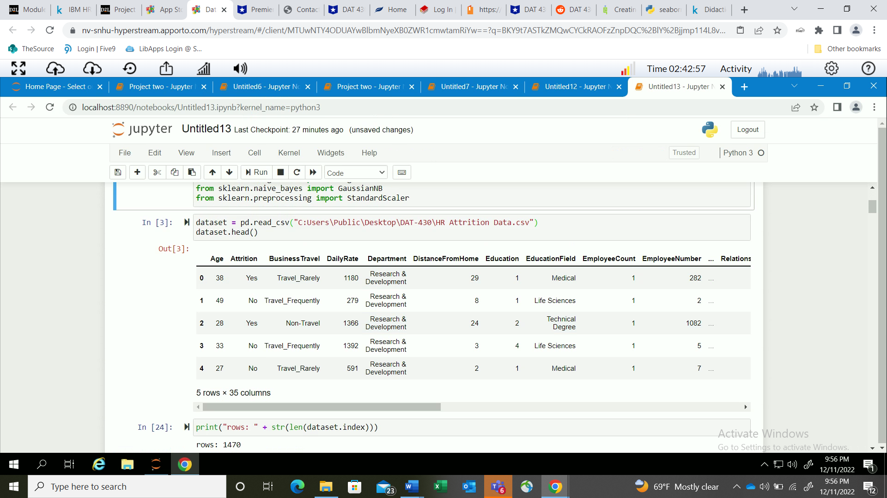

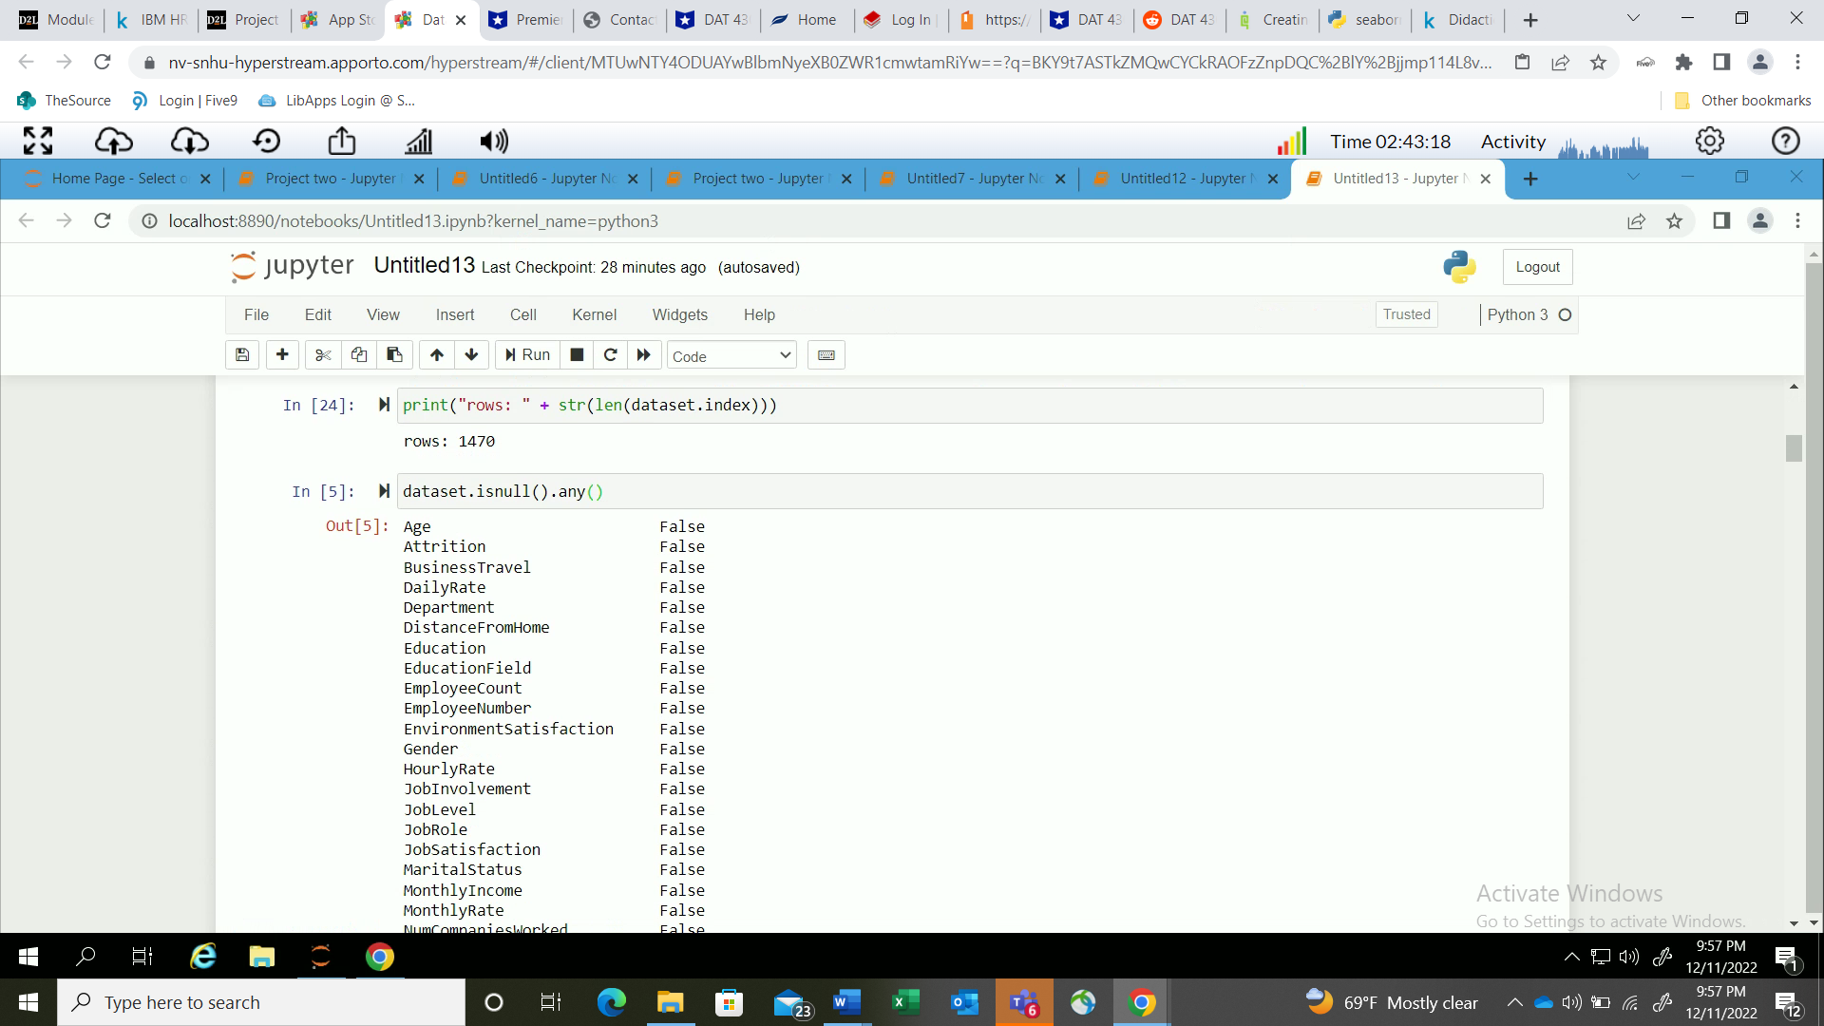

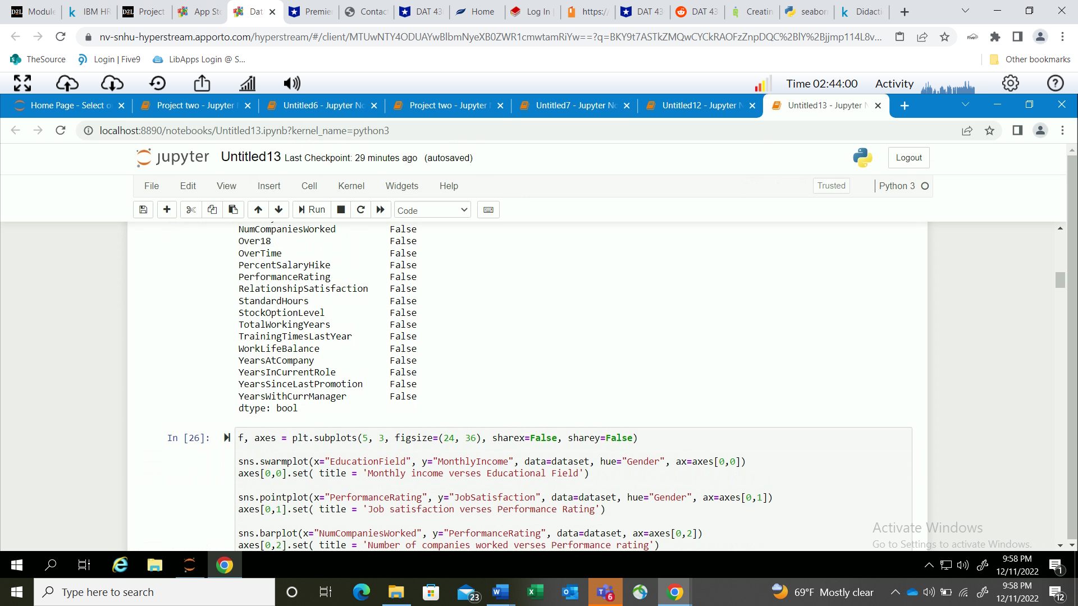

Next with the EDA. I have created a Mechine Learning Model that shows the codes and diffrernt graphs that were produced with the codes runned against each variables. With some questions in mind such as do we need all the features? Can features be combined? Are their relaions with the features? We can test our hypothesis by running models a visulizing our graphs to make out interpetations.

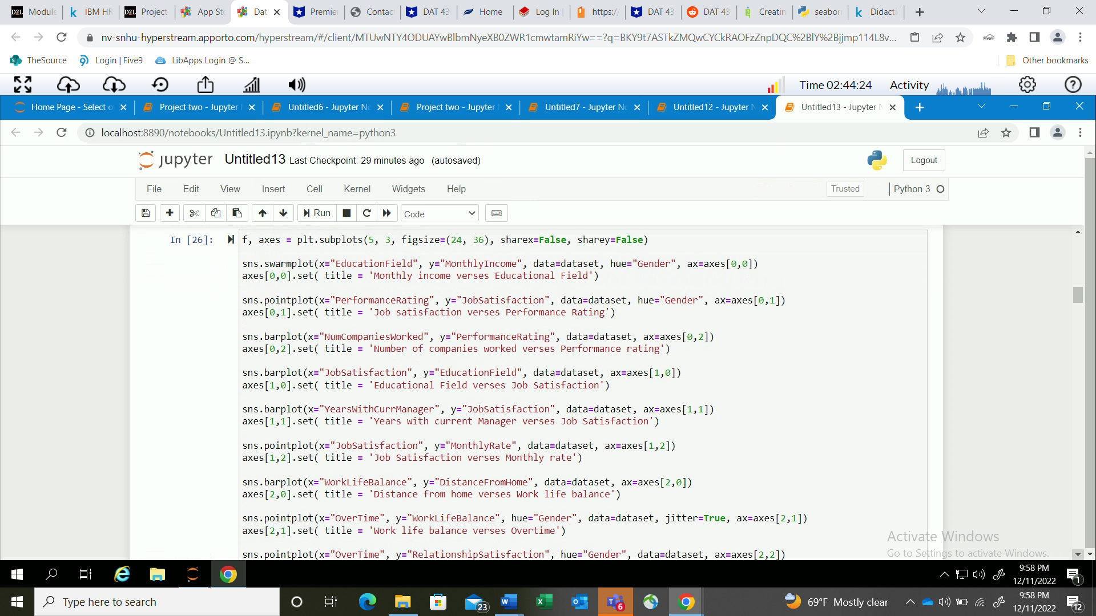

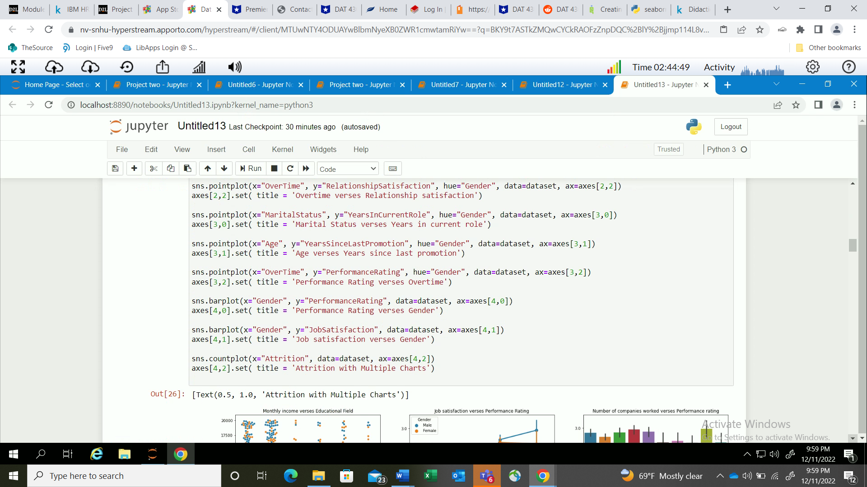

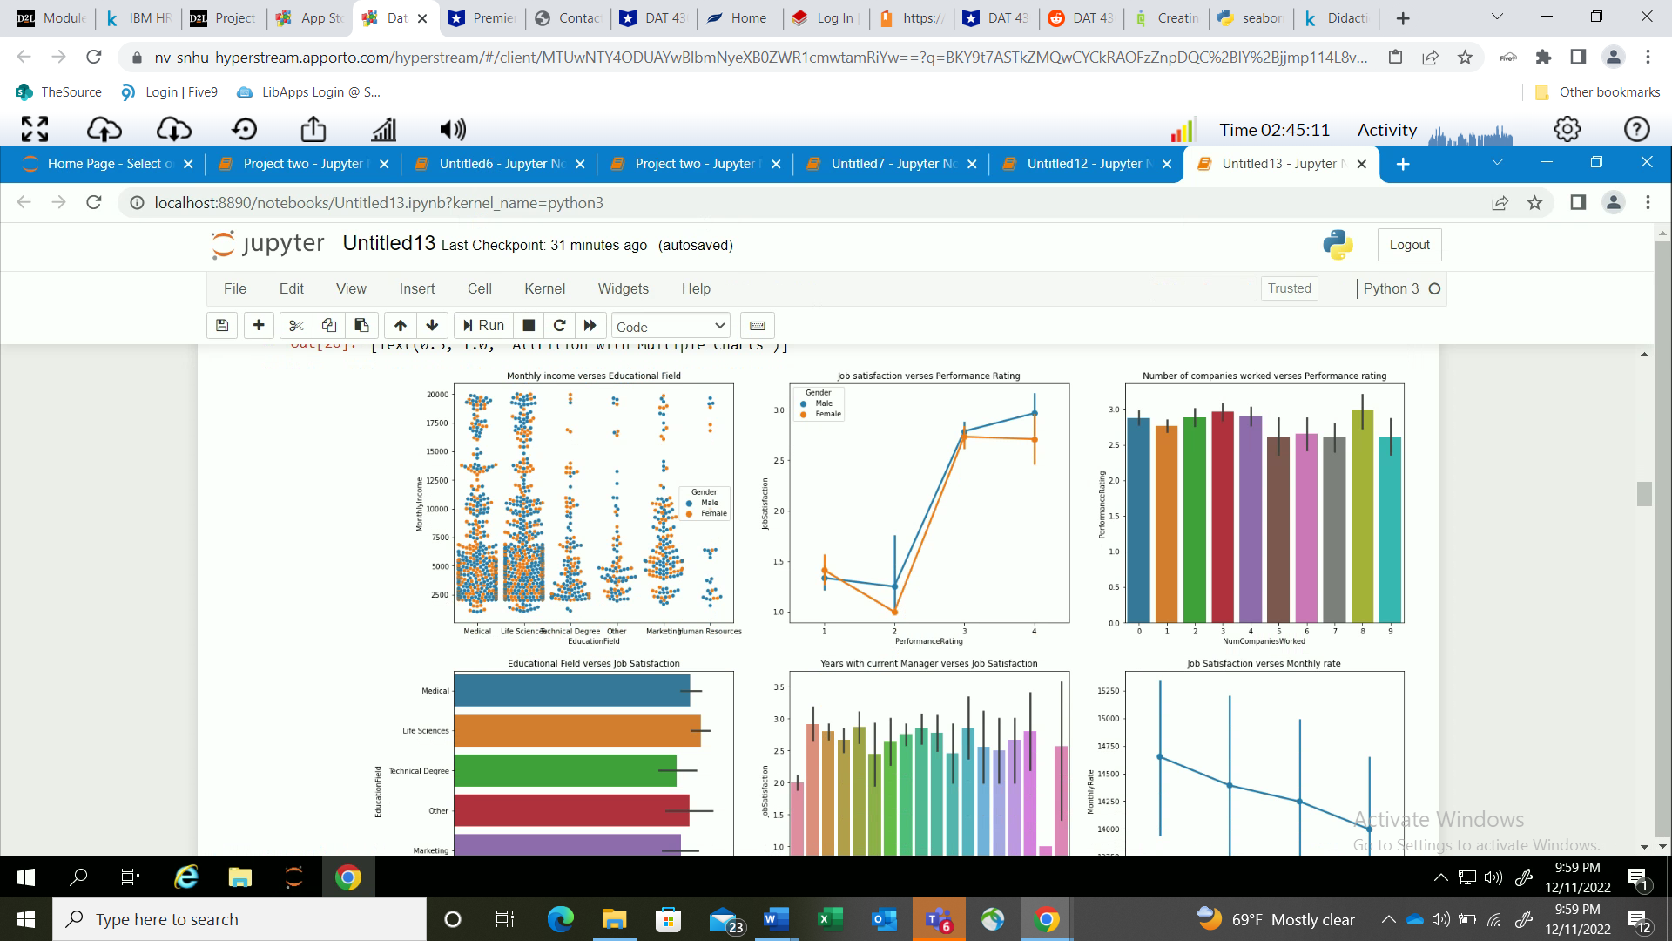

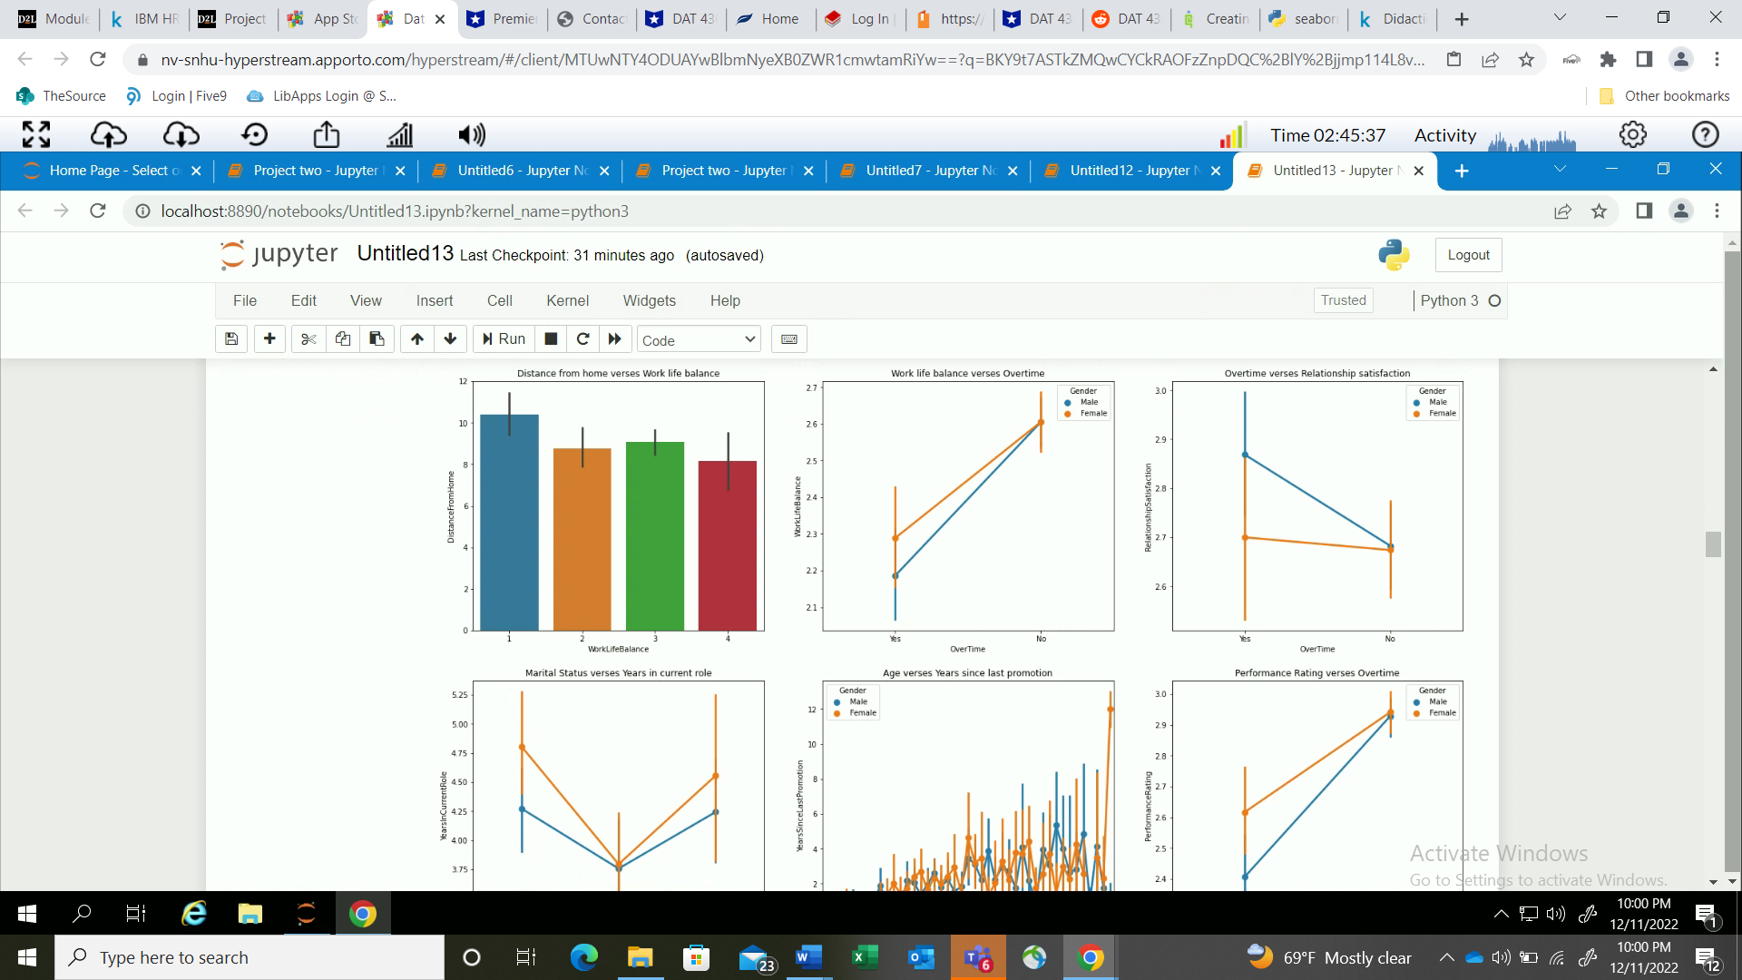

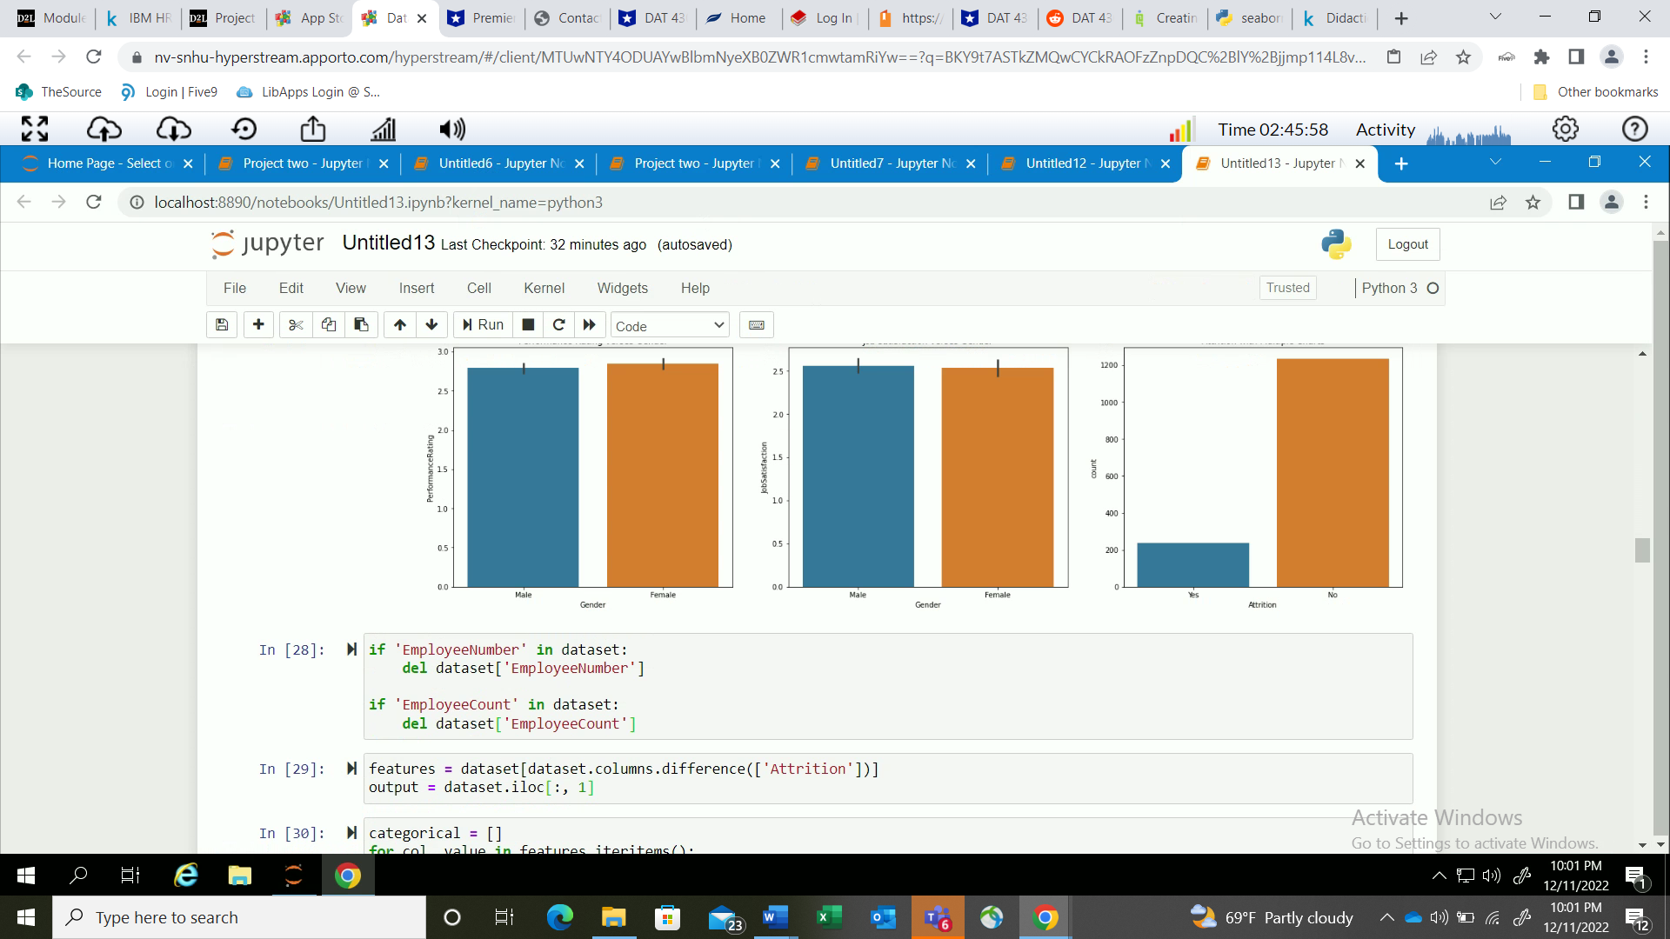

With the screen shots placed above it shows our analysis of features as well as graphs to can be looked at with ease to see different trends and patterns. Next, with skill and practice. We can do a teacnique called feature engineering. In short, it helps us to decide which feautres to keep and transform categorical data to numerical standards. Codes and screen shots are provided below.

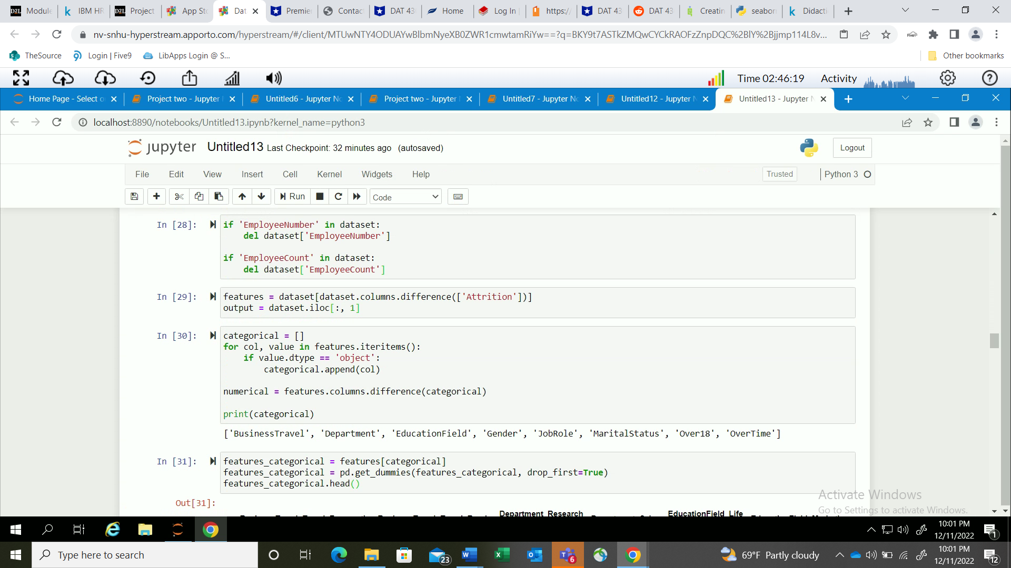

With the screen shots above depicting the feature engineering. We can than proceed to do another technique called encoding. Which, in short is converting the data into numerical standards. The results are in the screen shots that are below.

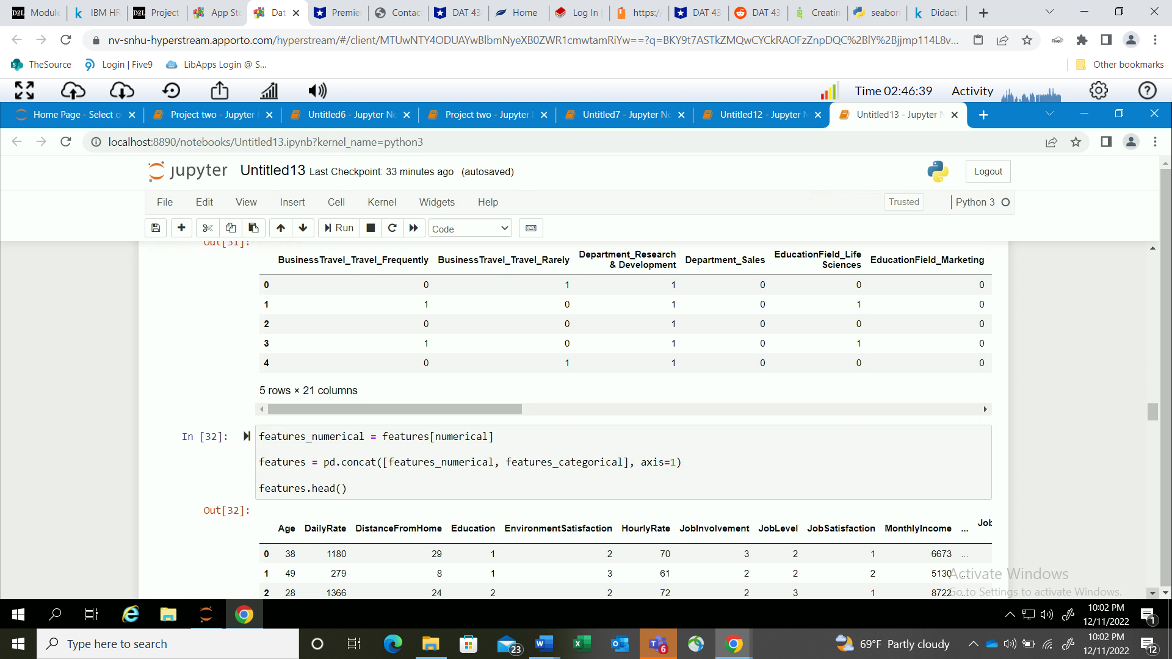

Building further upon the encoding. There are other sets of codes that we can use to further generate outputs that are using variables. Which are shown below. Then, we can proceed to do a random forest which is a technique that is great to use when an immense amount of data is being used and that has many features. We can also do prediction models with a decision tree model to find unknowns and see how well it performs with the original dataset. We got a prediction accuracy of 100%. Which is very great! We must as well measure the accuracy of such predictions with a confusion matric.

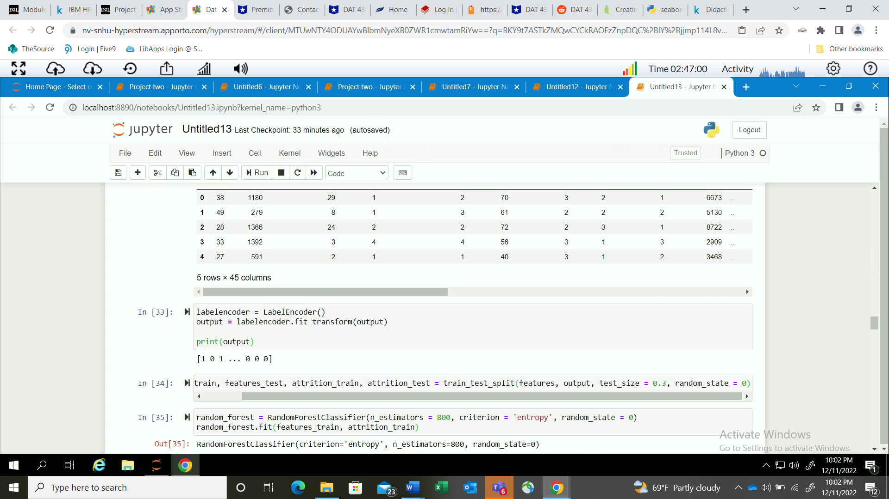

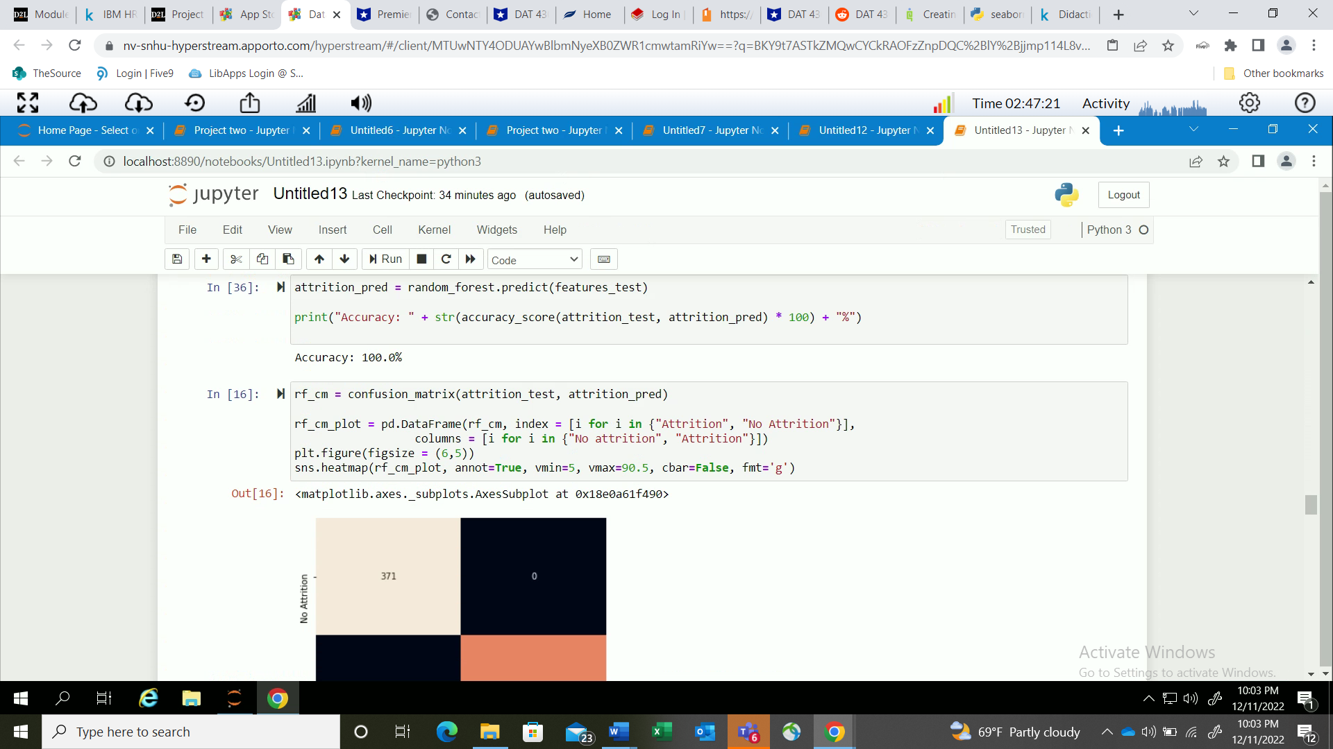

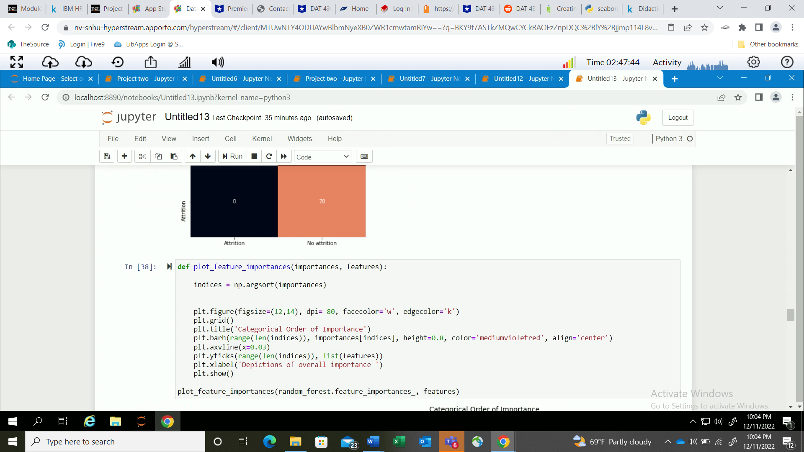

With the screen shot above. I have placed a code the weighs the features. Which we can look at to make improvements. With the screenshot below. We can see a graph with all the features that can either be eliminated or expanded further upon. The graph is simple to understand since we can measure the graph and results with order of importance. We also have to be made aware of features and some features having a high correlation with one another.

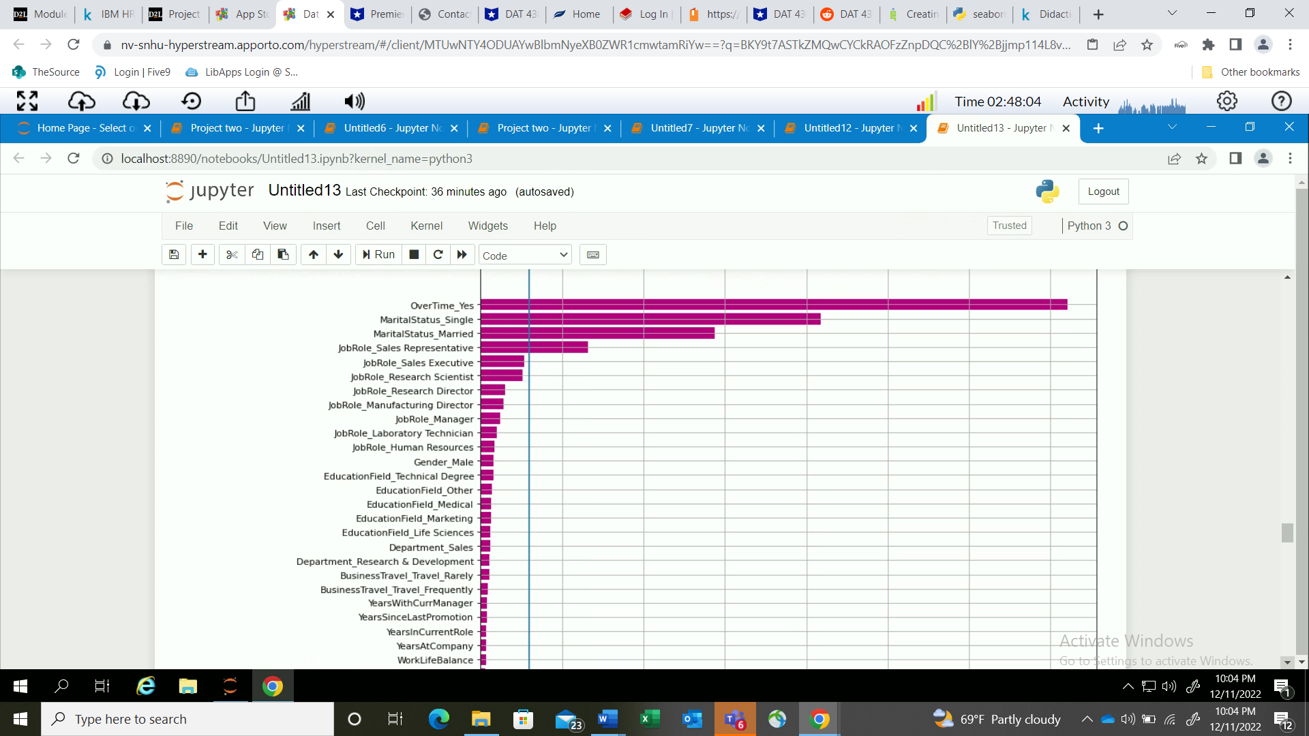

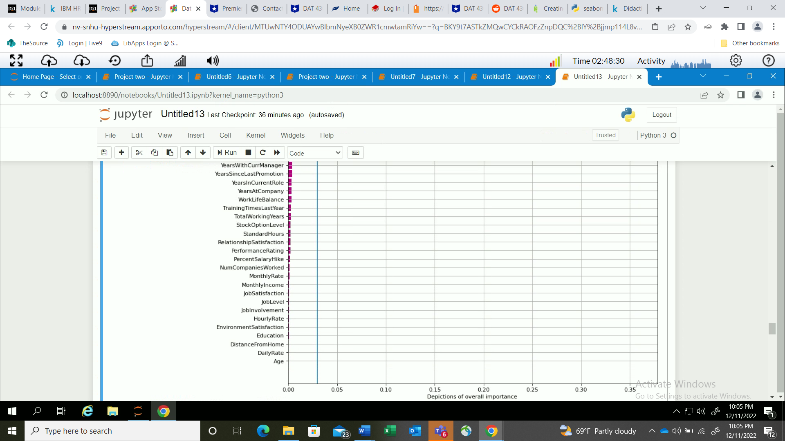

With the screenshot below. I have placed a code that has the new features that I deemed to make the most sense and filtered out the other features that are not deemed as important. This is only made possible by manipulating the previous datasets with desirable inputs. Next, we should do a train-step and split the data to train our newer models. After, we can re-train the dataset with a random forest to get better results.

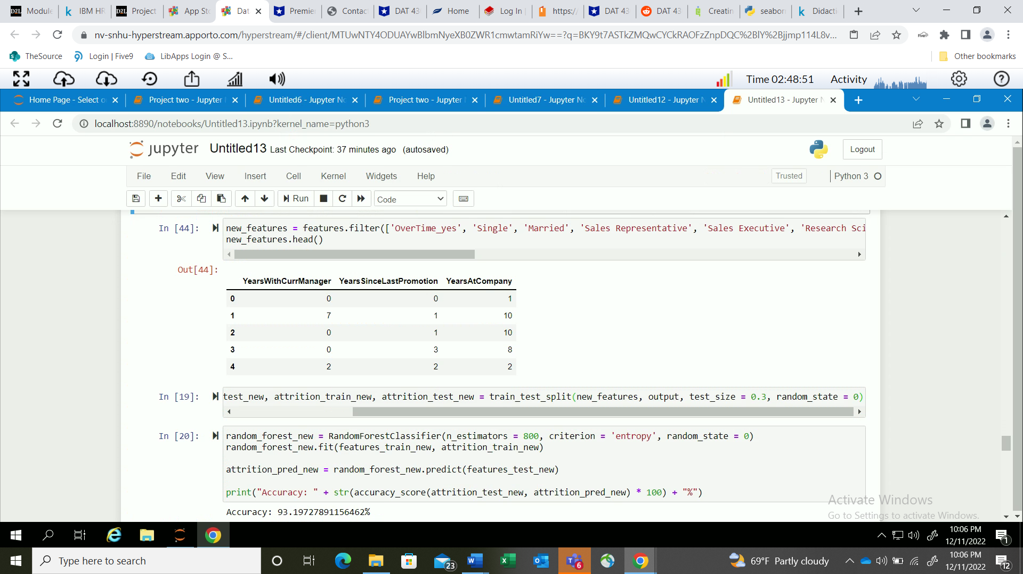

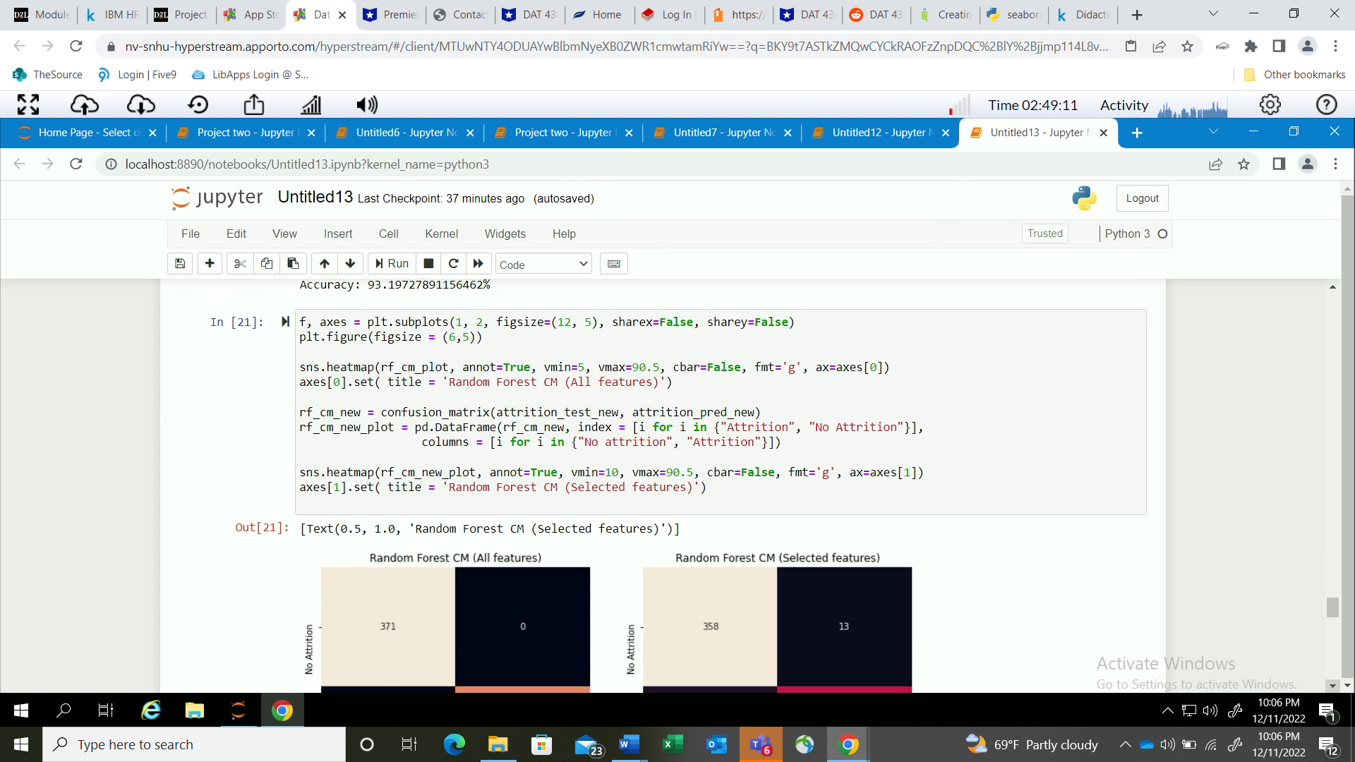

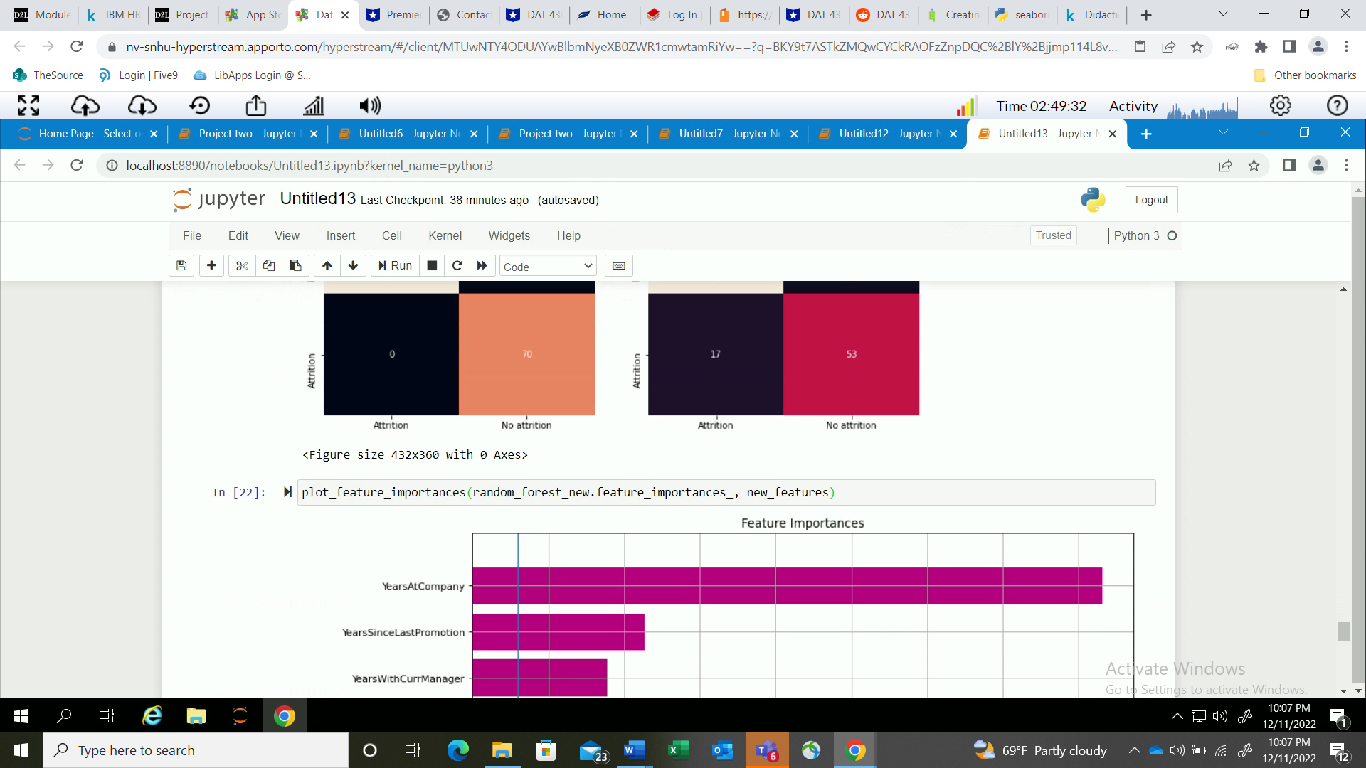

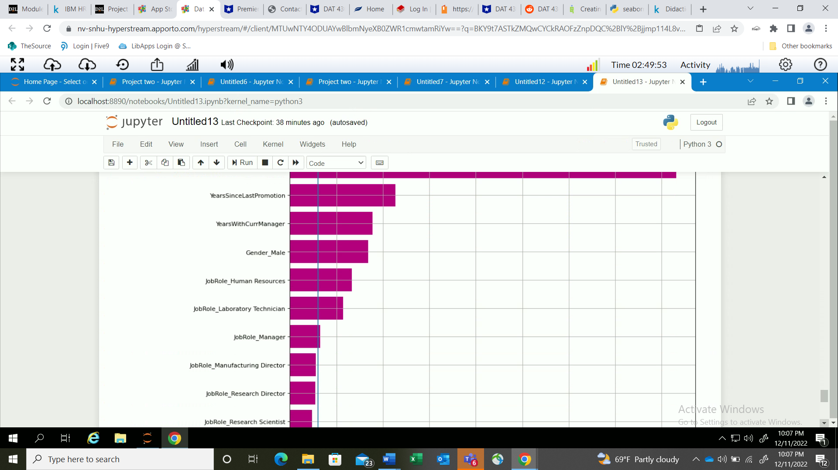

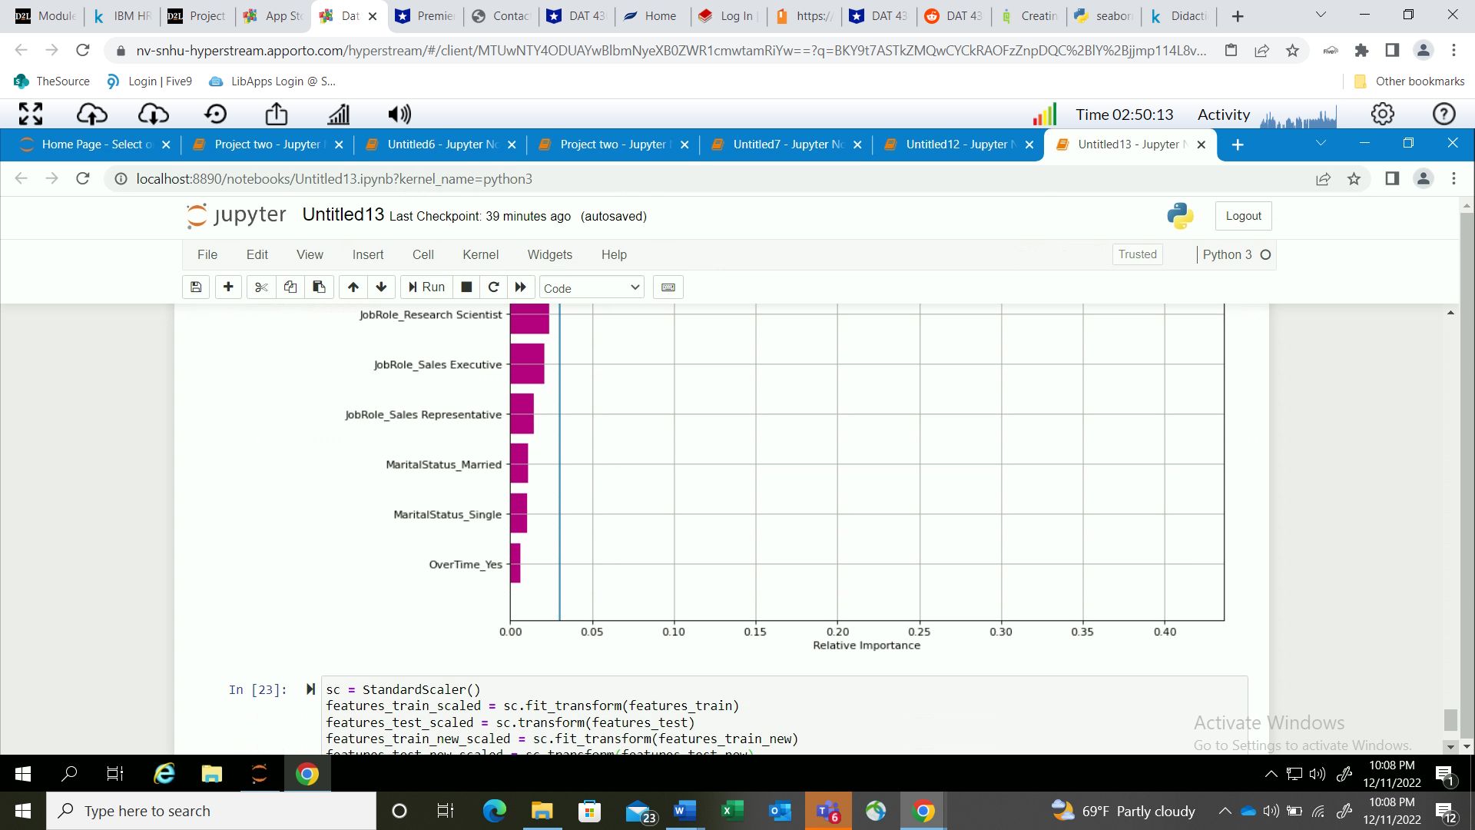

With the screen shot depicting the new graph of the new features. Some of the older features may had been over evaluated. This new graph above shows that employees that have tenure with the company tend to cause more of a nun sense which shows that the employees may not be happy with the same routine over a period. Also, with this change in features. It shows that job roles are not of importance with features creations. More work can be done, and the graphs can be further fine-tuned. But I have hit a wall with my codes and seem that I can’t overcome such matter within a reasonable time. I can also raise a question and urge the company to increase compensation salaries to employees to keep them satisfied and retain talent for the company for the long run. As well as incorporating quarterly bonuses and different stock options. Lastly, hiring new talent can reduce overall workload for tenure employees and help to minimize turnover rates as the graphs do show that over time does diminish an employee quality of work and have negative effects.

